**Vision Report:**

**Task 1:**

To find how the 2D pixel frame is related to the 3D world frame, camera calibration is performed. To do that, an intrinsic parameter matrix is introduced to describe the relationship between the image formed in the camera and the real object, which is exclusive to one camera.

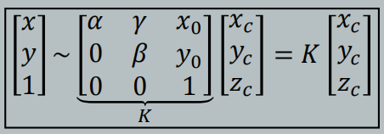

Figure 1: Intrinsic Parameter Matrix K

Besides, the extrinsic parameters are introduced to describe the position of the object in the camera coordinates with respect to the world frame in the following form.

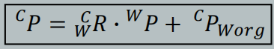

Figure 2: Description of the Same Point in Different Frames

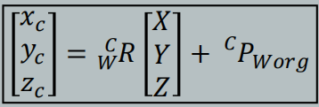

Figure 3: Extrinsic Parameters

Two sets of parameters are combined to describe the 2D points with respect to the world frame. K is the intrinsic matrix.

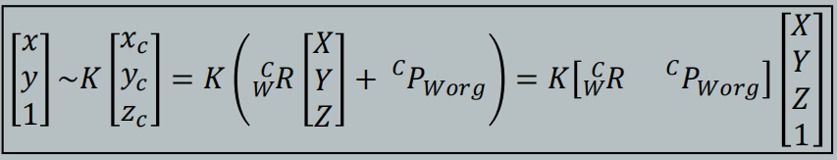

Figure 4: Camera Matrix Combining Intrinsic and Extrinsic Parameters

In this case, the checkerboard data is provided. By holding the checkerboard directly towards the camera (i.e. normal of the board in the same line as the direction of the camera) and the x-axis parallel to the ground, the position is set to be the working position and the board in this position is thus the object in the calibration.

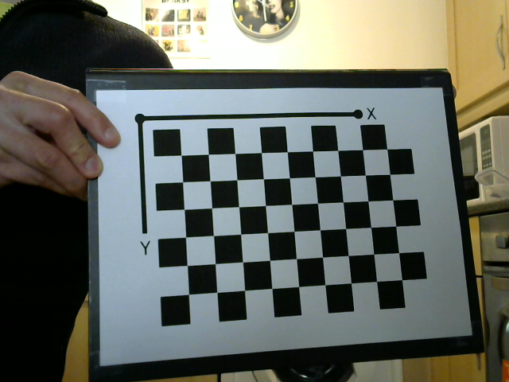

Figure 5: Checkerboard working position

The board is set to lie on the X-Y plane of the world frame, so all the points on the board have a Z-value of 0, which means the camera matrix can be simplified to the following. K is still the intrinsic matrix.

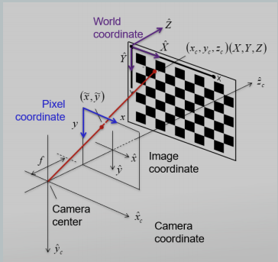

Figure 6: Diagram of Frames with World Frame Specified

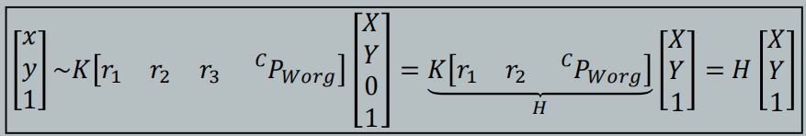

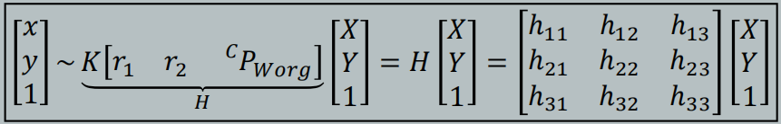

Figure 7: Camera Matrix Simplification

To simplify, the K intrinsic matrix combined with extrinsic parameters to form an H matrix called the camera matrix. In this task, we have 6 pictures in total, so we have 1 set of intrinsic and 6 sets of extrinsic parameters (which describe checkerboard pictures taken at different positions and orientations) or 6 camera matrices.

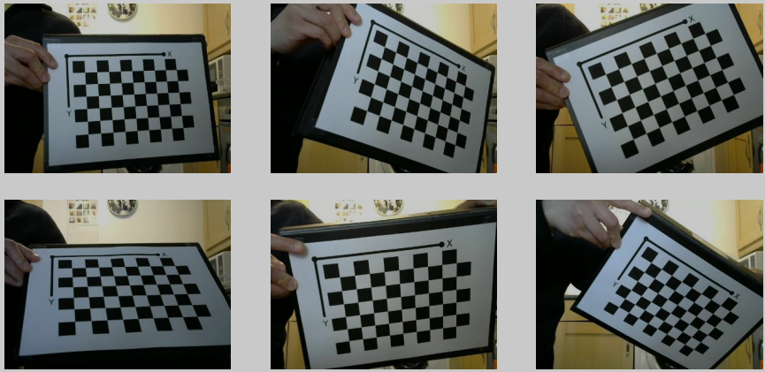

Figure 8: All Six Images

To obtain the intrinsic and extrinsic parameters, the 6 images are given and processed to obtain sets of (x, y, X, Y) to solve the camera matrix, which later can be used to recover both intrinsic and extrinsic parameters.

For X and Y (coordinates in the world frame), we use the "detectCheckerboardPoints()" function to extract the board row and column (boardSize) of the boards as a 1x2 vector [row column]. The length of the side of square blocks is *a priori* (22mm). Thus each exact point coordinates in the board are obtained. Since the Z values of points on the board are 0, as we discussed, the coordinates obtained are the coordinates of board points in the world frame.

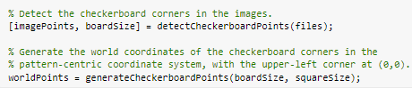

Figure 9: The Code to Extract the Point Data

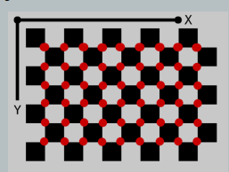

Figure 10: Points Labelled

The point coordinates (pixel positions) of all 6 figures with respect to the frame of each image are also obtained in the vector imagePoints. These form the xi and yi value sets.

Since the equation is in proportionality which cannot be solved directly, the solution turns into solving the cross multiplication of two vectors on both sides, which would equal 0 since:

$A×k*A = \left|A\right|⋅\left|A\right|⋅k⋅Sinθ=\left|A\right|⋅\left|A\right|⋅k⋅Sin0 = 0$

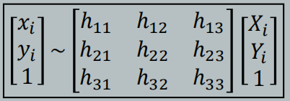

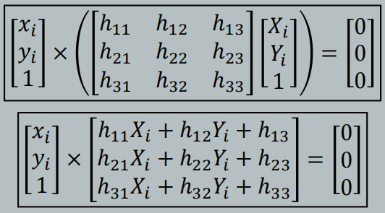

Figure 11: the Change in Solving H Matrix

Which gives:

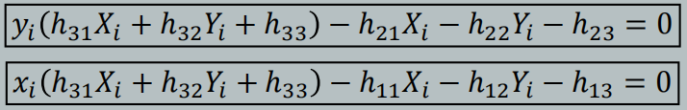

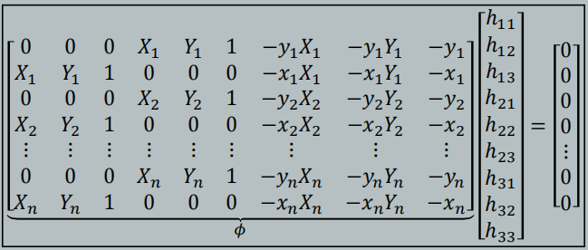

Figure 12: Rewrite of the Equation

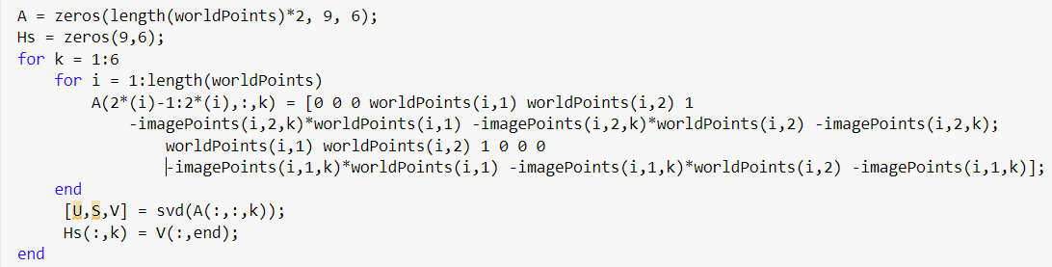

Figure 13: MATLAB Code of the Rewritten H Matrix

However, since the RHS of the equation is 0, the solution of the H matrix suffers from the trivial solution problem. This is solved by using singular value decomposition （SVD）.

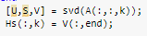

Figure 14: The Code of SVD

Recovering the intrinsic parameters:

We previously know that the intrinsic and extrinsic parameters are combined to be H matrix – the camera matrix



Figure 15: H Matrix

The matrices can be rewritten into a matrix of column vectors.

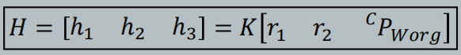

Figure 16: Column Vectors

The rotational matrix on the RHS of the equations can be inspected as follows (XYZ-fixed angles):

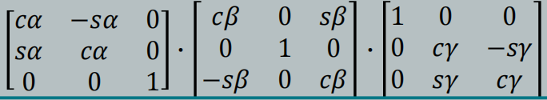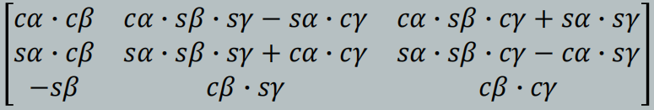

Figure 17: Rotational Matrix

If we take r1 as the first column and r2 as the second column, then we find the following three equations:

$$r_{1}^{T}r_{2}=\left[cαcβ sαcβ -sβ\right] {\left[cαsβsγ-sαcγ sαsβsγ+cαcγ cβsγ\right]}^{T}$$

$$=\left[cαcβcαsβsγ-cαcβsαcγ + sαcβsαsβsγ+sαcβcαcγ - sβcβsγ\right]$$

$$=\left[cβsβsγ\left(cαcα+sαsα\right)-sβcβsγ\right]$$

$$=\left[cβsβsγ-sβcβsγ\right]$$

$$=0$$

$$r_{1}^{T}r_{1}=\left[cαcβ sαcβ -sβ\right] {\left[cαcβ sαcβ -sβ\right]}^{T}$$

$$=\left[cαcβcαcβ+sαcβsαcβ+sβsβ\right]$$

$$=\left[cβcβ\left(cαcα+sαsα\right)+sβsβ\right]$$

$$=\left[cβcβ+sβsβ\right]$$

$$=1$$

$$r_{2}^{T}r_{2}=\left[cαsβsγ-sαcγ sαsβsγ+cαcγ cβsγ\right]{\left[cαsβsγ-sαcγ sαsβsγ+cαcγ cβsγ\right]}^{T}$$

$$=\left[{\left(cαsβsγ-sαcγ\right)}^{2}+{\left(sαsβsγ+cαcγ\right)}^{2}+{\left(cβsγ\right)}^{2} \right]$$

$$={\left(cαsβsγ\right)}^{2}-2cαsβsγsαcγ+{\left(sαcγ\right)}^{2}+{\left(sαsβsγ\right)}^{2}+2sαsβsγcαcγ+{\left(cαcγ\right)}^{2}+{\left(cβsγ\right)}^{2}$$

$$={\left(cαsβsγ\right)}^{2}+{\left(sαcγ\right)}^{2}+{\left(sαsβsγ\right)}^{2}+{\left(cαcγ\right)}^{2}+{\left(cβsγ\right)}^{2}$$

$$={\left(sβsγ\right)}^{2}+{\left(cγ\right)}^{2}+{\left(cβsγ\right)}^{2}$$

$$={\left(sγ\right)}^{2}+{\left(cγ\right)}^{2}$$

$$=1$$

From the first equation and the H matrix written in column vector form, we can derive that:

$$h_{1}=Kr_{1},h_{1}^{T}={\left(Kr_{1}\right)}^{T}=r_{1}^{T}K^{T},r_{1}^{T}=h_{1}^{T}K^{-T}$$

$$h_{2}=Kr_{2},r_{2}=K^{-1}h_{2}$$

$$r_{1}^{T}r_{2}=h_{1}^{T}K^{-T}K^{-1}h_{2}=0$$

$$r_{1}^{T}r_{1}=h_{1}^{T}K^{-T}K^{-1}h_{1}=r_{2}^{T}r_{2}=h_{2}^{T}K^{-T}K^{-1}h_{2}=1$$

Upon the above, we define that:

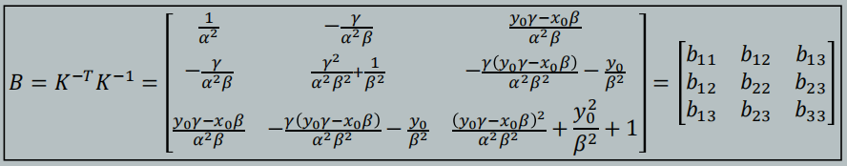Figure 18: Definition of B Matrix

B is a matrix with only 6 parameters as it is symmetric. Solving B matrix would allow us to recover K (intrinsic) parameters. Substituting the B into the equations above:

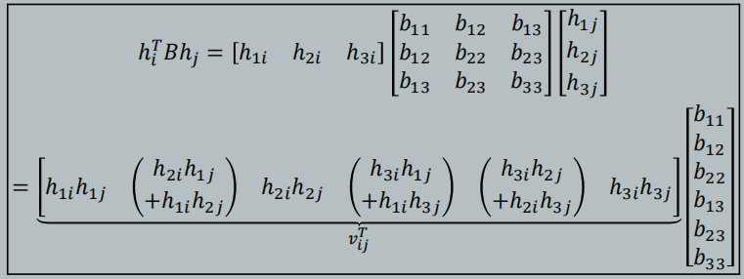

Figure 19: Substitution by B Matrix and Rewriting

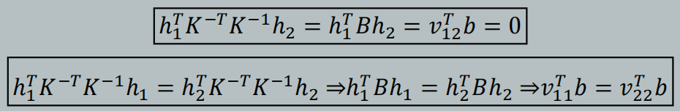

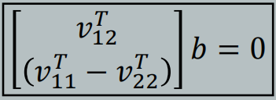

Figure 20: Simplification of the Substation

We have six sets of H matrices, which means we can have 6x2 equations describing the B matrix. Since the B matrix consists of only K (intrinsic matrix), B is also exclusive to the camera, i.e. B has only 1 solution.

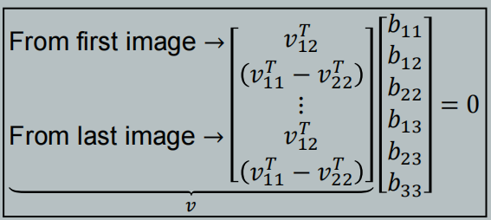

Figure 21: Aggregate of the Equations

Again, we use the SVD to solve the B matrix as the RHS is 0.

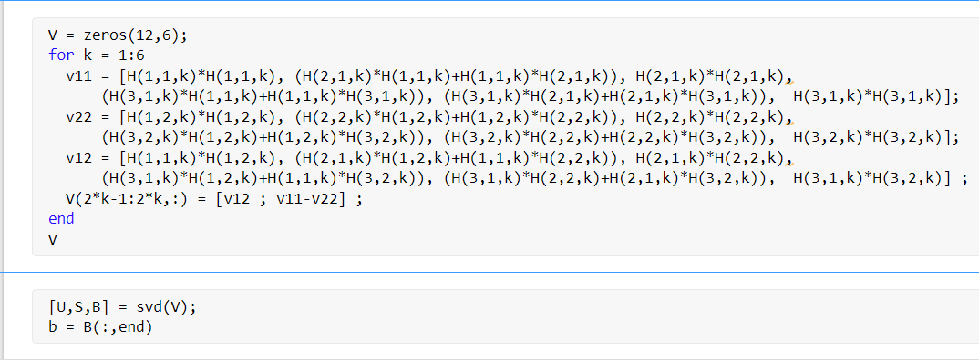

Figure 22: MATLAB Code of SVD Solution of the B Matrix and vijT Matrix

The B matrix solved here is multiplied by a scale factor, as the K matrix recovered from these B parameters would not set the k33 element to be 1 as we desired. Thus, a lambda parameter is introduced.

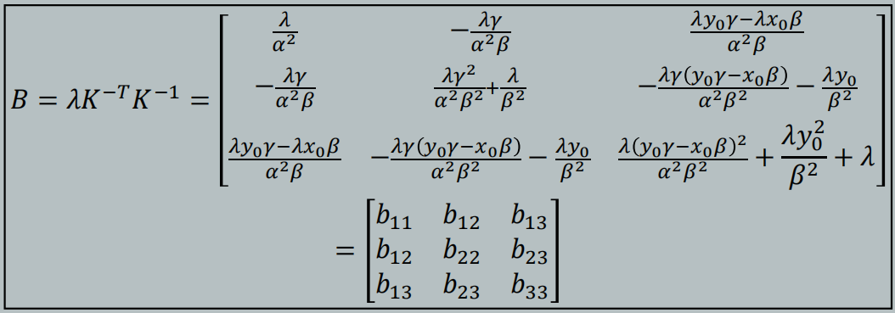

Figure 23: the Accurate Description of the B Matrix Solved

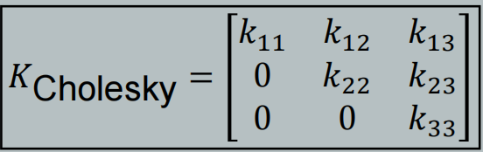

Figure 24: the K Matrix Recovered

Thus, the intrinsic parameters could be solved as follows:

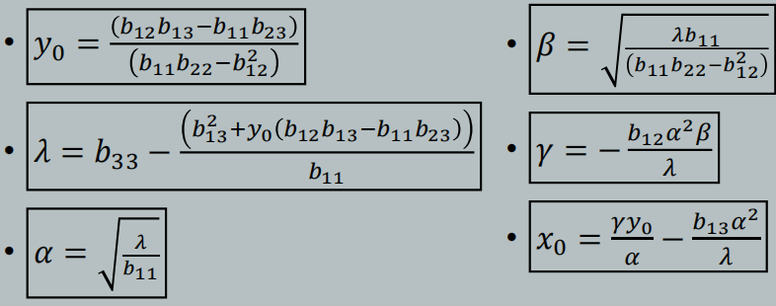

Figure 25: the Intrinsic Parameters Recovered

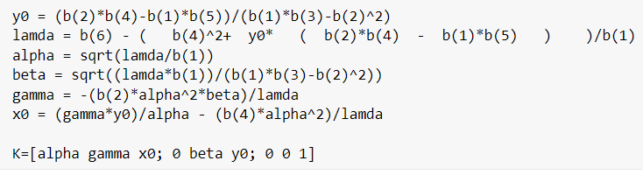

Figure 26: the Code to Recover the Intrinsic Parameters

Recovering the intrinsic parameters:

We have six sets of H parameters, yielding 6 sets of extrinsic parameters for 6 pictures.

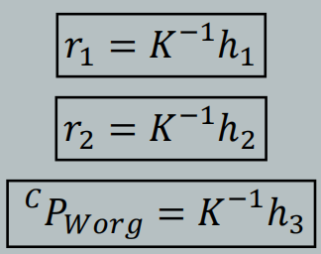

Figure 27: Recovering the Extrinsic Parameters

However, the parameters solved may not be in the correct scale. To obtain the correct scale, we recall that ||r1|| (modulus/length of the vector) should be 1

$${\left|\left|r_{1}\right|\right|}^{2}=\left[{\left(cαcβ\right)}^{2}+{\left(sαcβ\right)}^{2}+{\left(sβ\right)}^{2}\right]$$

$$=\left[{\left(cβ\right)}^{2}\left({\left(cα\right)}^{2}+{\left(sα\right)}^{2}\right)+{\left(sβ\right)}^{2}\right]$$

$$=\left[{\left(cβ\right)}^{2}+{\left(sβ\right)}^{2}\right]$$

$$=1$$

This means we can obtain the correct scale by deriving a scaling coefficient: ||rr1||/||K-1h1||.

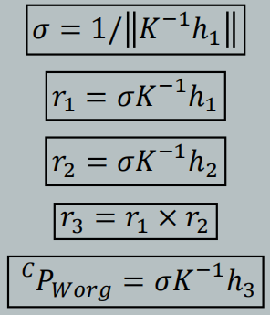

Figure 28: Recovering the Extrinsic Parameters in the Correct Scale

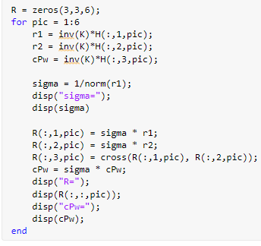

Figure 29: the Code to Recover the Extrinsic Parameters

Comparison with Toolbox:

A toolbox is used to perform calibration.

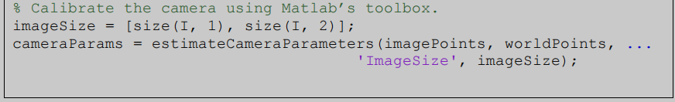

Figure 30: The Code of the Toolbox

The code is run, and the result is shown as follows.

Intrinsic:

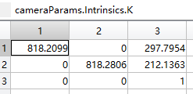

Figure 31: Intrinsic Parameters Calculated by the Toolbox

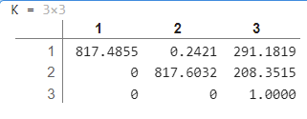

Figure 32: Intrinsic Parameters Calculated by the H Matrices

Extrinsic:

Image1:

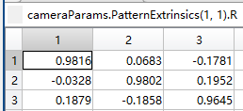

Figure 33: Extrinsic Parameters of the First Image Calculated by the Toolbox-Rotational Matrix

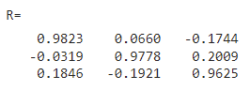

Figure: Extrinsic Parameters of the First Image Calculated by the H Matrix-Rotational Matrix

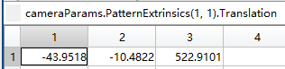

Figure 34: Extrinsic Parameters of the First Image Calculated by the Toolbox-Translation Vector

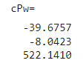

Figure 35: Extrinsic Parameters of the First Image Calculated by the H Matrix-Translation Vector

Image 2:

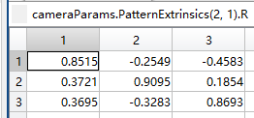

Figure 36: Extrinsic Parameters of the Second Image Calculated by the Toolbox-Rotational Matrix

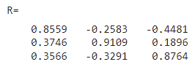

Figure 37: Extrinsic Parameters of the Second Image Calculated by the H Matrix-Rotational Matrix

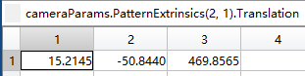

Figure 38: Extrinsic Parameters of the Second Image Calculated by the Toolbox-Translation Vector

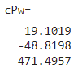

Figure 39: Extrinsic Parameters of the Second Image Calculated by the H Matrix-Translation Vector

Image 3:

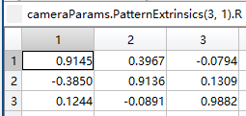

Figure 40: Extrinsic Parameters of the Third Image Calculated by the Toolbox-Rotational Matrix

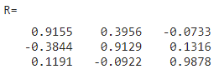

Figure 41: Extrinsic Parameters of the Third Image Calculated by the H Matrix-Rotational Matrix

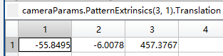

Figure 42: Extrinsic Parameters of the Third Image Calculated by the Toolbox-Translation Vector

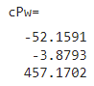

Figure 43: Extrinsic Parameters of the Third Image Calculated by the H Matrix-Translation Vector

Image 4:

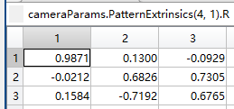

Figure 44: Extrinsic Parameters of the Fourth Image Calculated by the Toolbox-Rotational Matrix

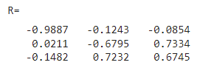

Figure 45: Extrinsic Parameters of the Fourth Image Calculated by the H Matrix-Rotational Matrix

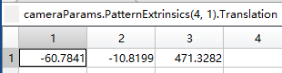

Figure 46: Extrinsic Parameters of the Fourth Image Calculated by the Toolbox-Translation Vector

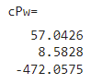

Figure 47: Extrinsic Parameters of the Fourth Image Calculated by the H Matrix-Translation Vector

Image 5:

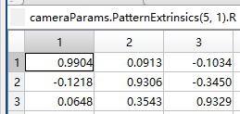

Figure 48: Extrinsic Parameters of the Fifth Image Calculated by the Toolbox-Rotational Matrix

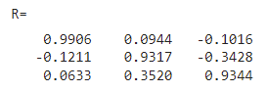

Figure 49: Extrinsic Parameters of the Fifth Image Calculated by the H Matrix-Rotational Matrix

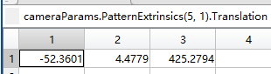

Figure 50: Extrinsic Parameters of the Fifth Image Calculated by the Toolbox-Translation Vector

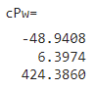

Figure 51: Extrinsic Parameters of the Fifth Image Calculated by the H Matrix-Translation Vector

Image 6:

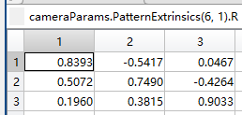

Figure 52: Extrinsic Parameters of the Sixth Image Calculated by the Toolbox-Rotational Matrix

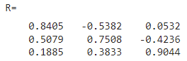

Figure 53: Extrinsic Parameters of the Sixth Image Calculated by the H Matrix-Rotational Matrix

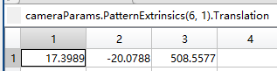

Figure 54: Extrinsic Parameters of the Sixth Image Calculated by the Toolbox-Translation Vector

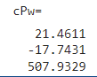

Figure 55: Extrinsic Parameters of the Sixth Image Calculated by the H Matrix-Translation Vector

As a result, the figures have some differences, but the values and magnitudes are very similar, concluding that the solution through the H matrix works.

The difference may be caused by the accuracy (number of decimal places) of figures and numbers used.

**Task 2:**

After finishing the camera calibration, we need to focus on the robot calibration.

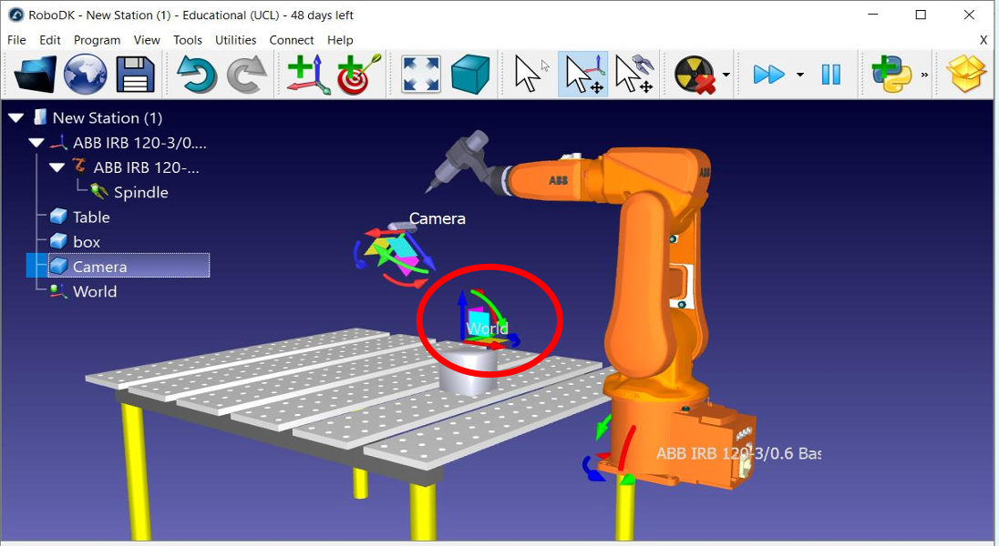

Figure 56: Graph for the camera calibration

Firstly, we place the checkerboard on the object and then jog the robot such that the end-effector TCP touches the corner points on the checkerboard.

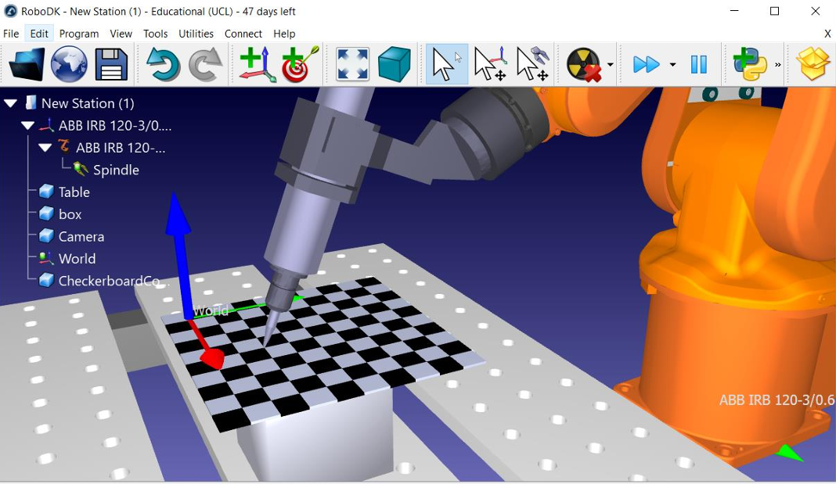

Figure 57: end-effector TCP touches the corner points on the checkerboard

For robot calibration, we need to find the relationship between the 3D robot frame with the 3D world frame. When the TCP touches the corner point I, we can find out the position of the TCP $\left[X_{ri} Y_{ri }Z_{ri}\right]$ with respect to the robot frame by using forward kinematics. The position of the corner point $\left[X_{i} Y_{i }0\right]$ with respect to the World frame are known.

The graph below shows the relationship between the robot frame and the world frame.

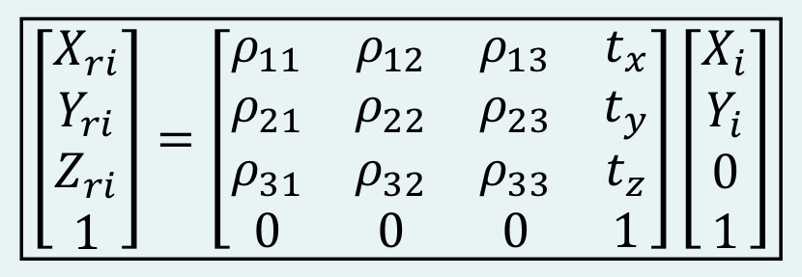

Figure 58: Relationship between the robot frame & world frame

Six points are sampled to give their coordinates in world origin and in the robot frame. The Arduino code used here is using a potentiometer and directly outputs the robot frame coordinates, so there’s no need to use forward kinematics.

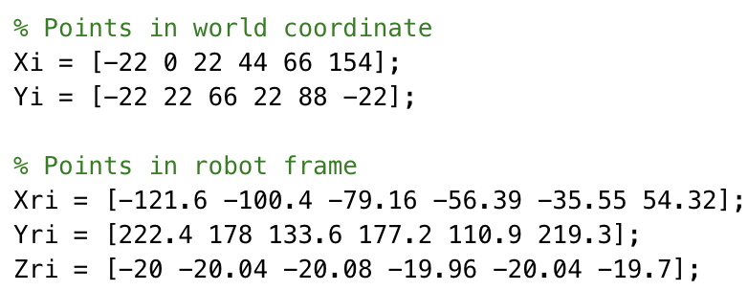

Figure 59: Given values for the robot frame & world frame

To solve for two unknown parameters $ρ$ and $t$, we use the method proposed by Cashbaugh et al.

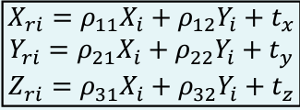

Figure 60: Individual linear equations

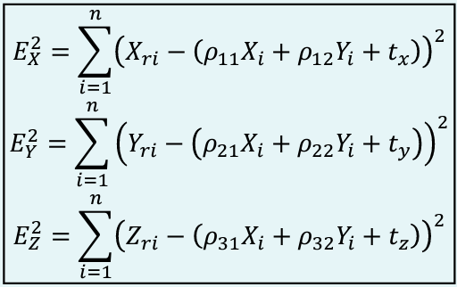

Figure 61: Obtain unknown parameters by minimizing the square of errors

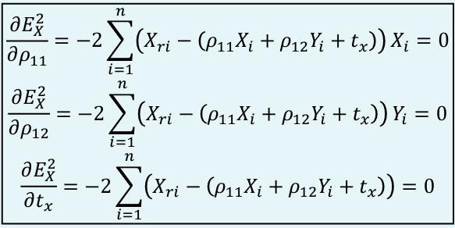

Figure 62: The minimum value occurs when the derivatives are zero

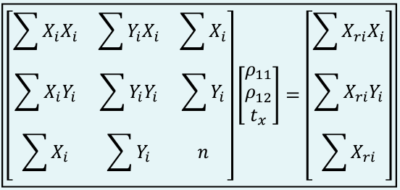

Figure 63: Transformation of the equation and its matrix form

Then rewrite the equation and write into matrix form:

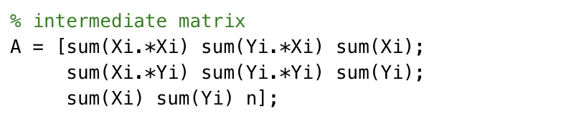

Figure 64: The intermediate matrix in MATLAB

As we have six points selected on the checkboard, $n=6$

To calculate matrix $\left[ρ_{11} ρ_{12} t_{x}\right]$, we use the $E_{X}^{2}$ and the equation below is from the lecture notes (page 88).

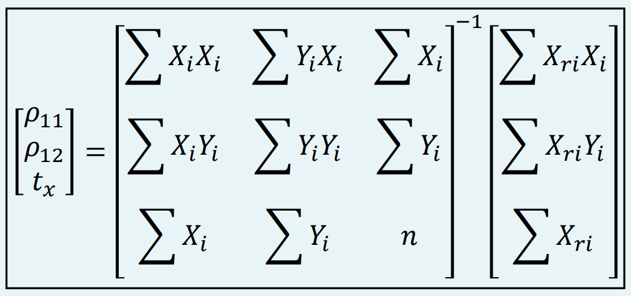

Figure 65: matrix form for $E_{X}^{2}$ to calculate the rotation and translation parameters

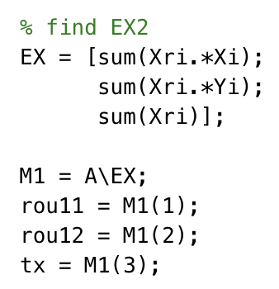

Figure 66: the MATLAB code to calculate $ρ_{11}$, $ρ_{12}$, $t_{x}$

To calculate matrix $\left[ρ_{21} ρ_{22} t_{y}\right]$, we use the $E_{Y}^{2}$ and the equation below is from the lecture notes (page 89).

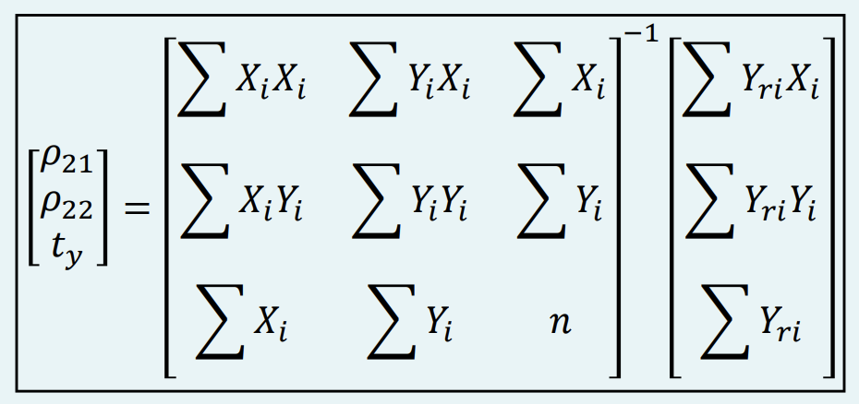

Figure 67: matrix form for $E_{Y}^{2}$ to calculate the rotation and translation parameters

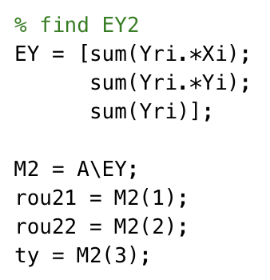

Figure 68: the MATLAB code to calculate $ρ_{21}$, $ρ_{22}$, $t_{y}$

To calculate matrix $\left[ρ_{31} ρ_{32} t_{z}\right]$, we use the $E_{Z}^{2}$ and the equation below is from the lecture notes (page 90).

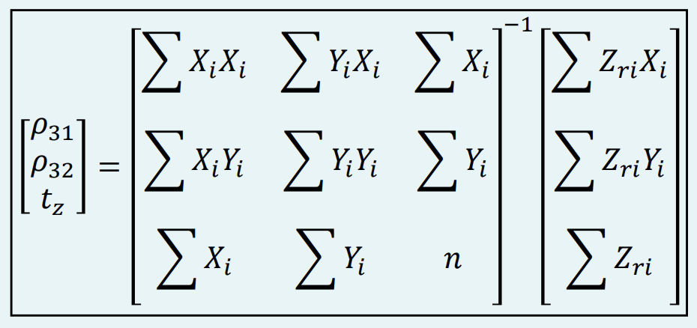

Figure 69: matrix form for $E_{Z}^{2}$ to calculate the rotation and translation parameters

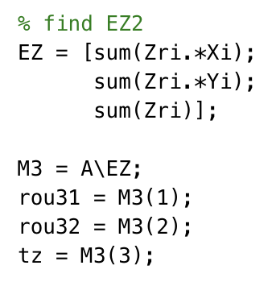

Figure 70: the MATLAB code to calculate $ρ_{31}$, $ρ_{32}$, $t_{z}$

Finally, $\left[ρ_{13} ρ_{23 }ρ_{33}\right]$ Can be calculated as the cross product of two vectors below:

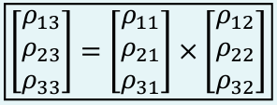

Figure 71: Equation for calculating $\left[ρ_{13} ρ_{23 }ρ_{33}\right]$

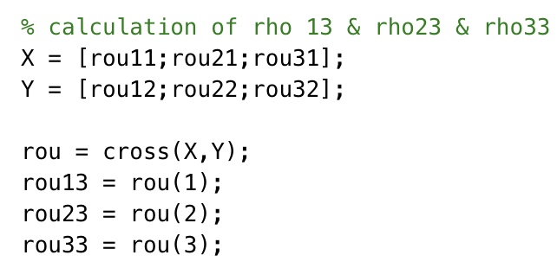

Figure 72: Calculation for the $\left[ρ_{13} ρ_{23} ρ_{33}\right]$

The code above is in MATLAB to calculate the required parameters.

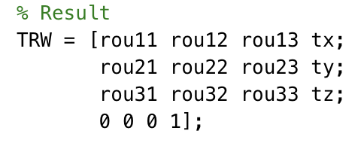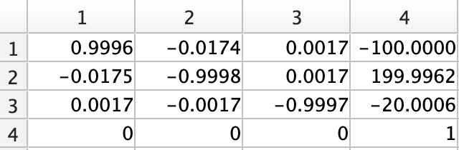

Figure 73: General expression for the Trw and final answer of the Trw matrix

The left figure above is the general matrix expression for the unknown parameters, and the right figure is the final values displayed by the right-hand side matrix.

**Task 3:**

Task 3 needs to find the position, orientation, circularity, edges and corners of the given object.

The real-world image varies continuously in shades and colours. Using digital camera to take the picture, the continuous image is obtained and divided into discrete points of brightness, 255 marks for pure white and 0 marks for pure black.

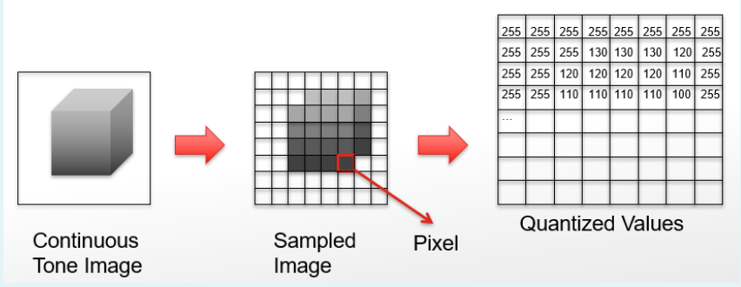

Figure 74: Using digital data value to describe Brightness of each point

The image is sampled into a 2-dimensional array of pixels, x is positive from left to right, y is positive from top to bottom. Most importantly, the Matlab's notation for matrix element is (row, column), thus x and y are swapped.

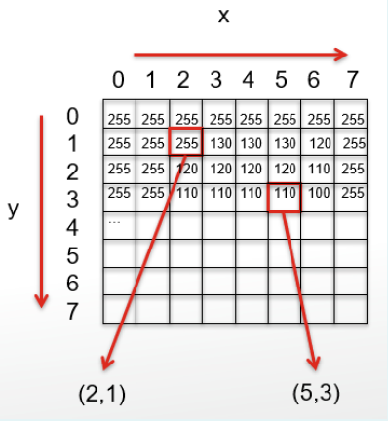

Figure 75: the Coordinate (x,y) of Each Pixel

Firstly, we need to import the image and show it.

%%%%%%%%%%%%%%%%

% Import Image %

%%%%%%%%%%%%%%%%

I = imread('Object.png');

figure, imshow(I)

title('rectangular')

Next, we use the histogram of brightness as a guide. The graph shows that setting any pixel values smaller than 75 as 0, and any larger than 75 as 255 is a good idea for thresholding.

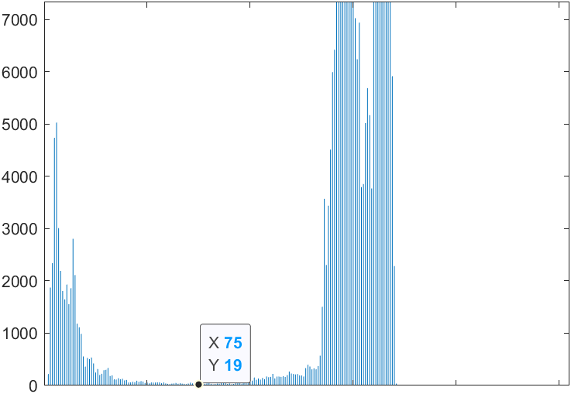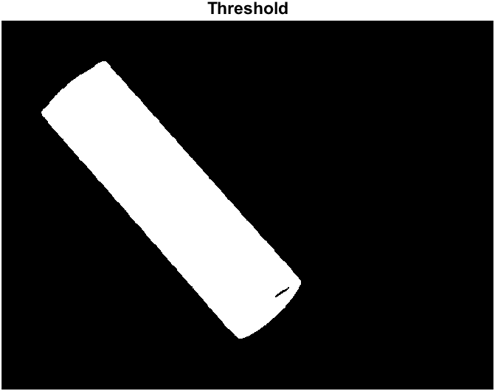

Figure 76: Histogram of Original image and Thresholding image

The thresholding image shows that there is a black noise area within the outer rectangular shape. Therefore, we need to implement a noise filter to eliminate the noise within our object. The Low Pass Filter and Gaussian Filter could only blur out the noises, the Median Filter becomes a better option in this scenario.

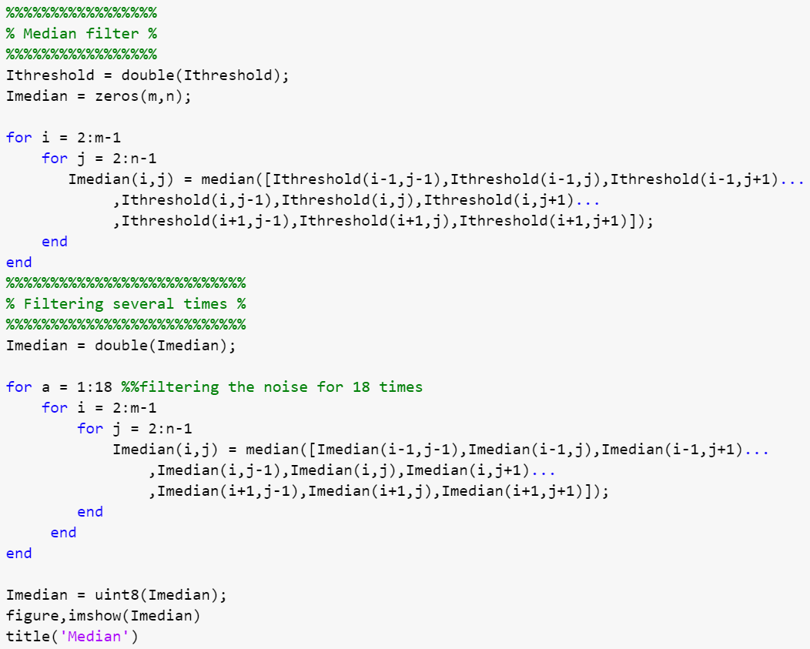

Figure 77: The MATLAB code for the Median filter

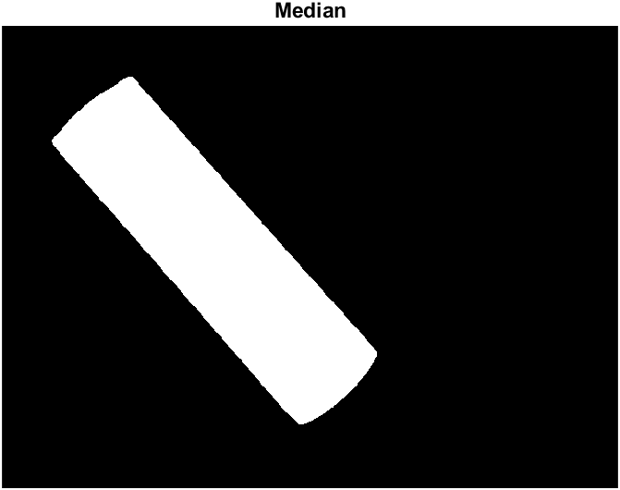

Figure 78: The image after Median filter

Filtering the noise by using the Median Filter one time could make the noise smaller. We could filter the image 18 times more to eliminate the noise inside the rectangular (for a = 1:18).

Then we could sharpen the images rather than blur it by using of sharpening mask.

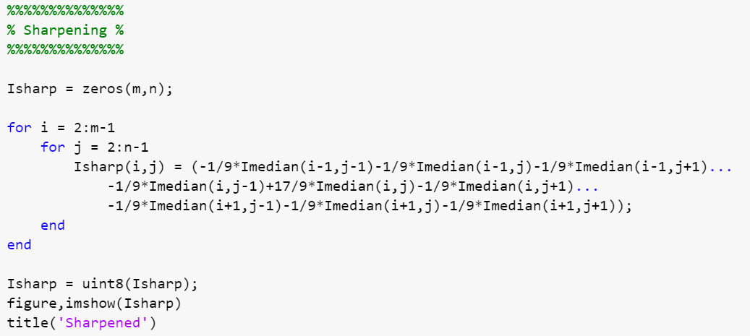

Figure 79: The MATLAB code for Sharpening the image

**Centroid**

The following tasks would be position, orientation, and circularity.

A good way to find the position of an object is using the moment method, a concept borrowed from physics, which accounts for the sum of the multiplication of the mass and distance with respect to the pivot point. Here we multiply the pixel value (mass/weight) with its distance from the origin.

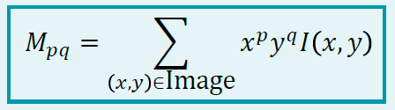

Figure 80: The p-q-th Moment of an image

M00 = 0;

for i= 1:m

for j = 1:n

M00 = M00 + Ibw(i,j);

end

end

The M00 is sum of Intensity I (x, y), as x0 = 1 and y0 = 1.

M10 = 0;

for i= 1:m

for j = 1:n

M10 = M10 + j.*Ibw(i,j);

end

end

M01 = 0;

for i= 1:m

for j = 1:n

M01 = M01 + i.*Ibw(i,j);

end

end

The M10 is j.*Ibw $\left(i,j\right)$. The power of x is 1 and the power of y is 0, since the MATLAB's notation for matrix element is (row, column), i.e. reverse to the (x,y) notation, x and y are swapped. So, Intensity should time $j$.

The M01 is i.*Ibw $\left(i,j\right)$. The power of y is 1 and the power of x is 0, thus the intensity should time $i$.



Figure 81: Formulae for the Centroid point

The centroid could be easily calculated by the formulae.

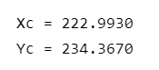

Figure 82: Centroid point of object

**Orientation**

Since the MATLAB's notation for matrix element is (row, column), x stands for column and thus *i*, and y stands for row and thus *j*.

The M02 is $x^{2}$.*Ibw $\left(i,j\right)$. The power of x is 0 and that of y is 2, so the intensity should time $i^{2}$.

The M20 is $j^{2}$.*Ibw $\left(i,j\right)$. The power of x is 2 and that of y is 0, so the intensity should time $j^{2}$.

The M11 is i.*j.*Ibw $\left(i,j\right)$. The power of x is 1 and that of y is 1, so the intensity should time $i∙j$.

M02 = 0;

for i= 1:m

for j = 1:n

M02 = M02 + i.^2.*Ibw(i,j);

end

end

M20 = 0;

for i= 1:m

for j = 1:n

M20 = M20 + j.^2.*Ibw(i,j);

end

end

M11 = 0;

for i= 1:m

for j = 1:n

M11 = M11 + i.*j.*Ibw(i,j);

end

end

After calculating the moments with respect to the origin (0,0) and the centroid position, we can calculate the moments with respect to the centroid which is Central Moment.

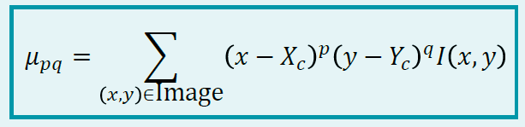

Figure 83: Formulae for the Central Moment

It can be shown below:

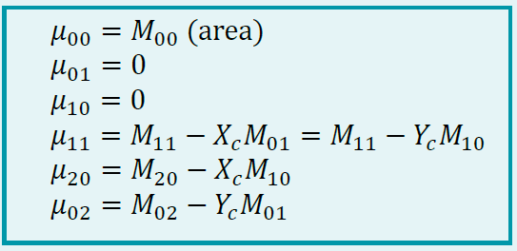

Figure 84: Formulae for $μ_{00}$, $μ_{01}$, $μ_{10}$, $μ_{11}$, $μ_{20}$, $μ_{02}$

We say a blob is continuous adjacent pixels with the same value, forming a region/connected component.

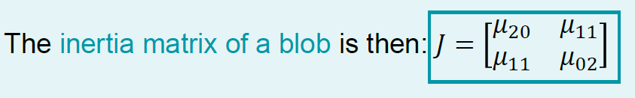

Figure 85: The Matrix Expression for the Inertia of a Blob $J$

u00 = M00;

u01 = 0;

u10 = 0;

u11 = M11 - Xc * M01;

u20 = M20 - Xc * M10;

u02 = M02 - Yc * M01;

J = [u20, u11;

u11, u02];

To find the orientation of the object, we need to find ellipse parameters. The ellipse parameters can be obtained from the inertia moments.

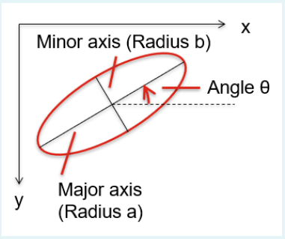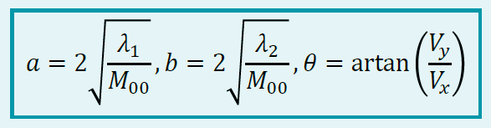

Figure 86: Ellipse Parameters Obtained from the Inertia Matrix

The $λ_{i}$ are eigenvalues of J in which $λ_{1}$ > $λ_{2}$, and $V=\left[V_{x} V_{y}\right]$ is the eigenvector of J, corresponding to $λ_{1}$.

[V,D] = eig(J)

if D(1,1) > D(2,2) %(1,1) is lambda 1

lambda1 = D(1,1)

lambda2 = D(2,2)

Vx = V(1,1)

Vy = V(2,1)

else %(2,2) is lambda 1

lambda1 = D(2,2)

lambda2 = D(1,1)

Vx = V(1,2)

Vy = V(2,2)

end

We should compare the eigenvalues of J and let the bigger value of $λ_{i}$ become $λ_{1}$, and the smaller value of $λ_{i}$ becomes $λ_{2}$. Then we can use the formula $θ=\tan^{-1}\left(\frac{V_{y}}{V_{x}}\right)$ to calculate the orientation of this object.

a = 2*sqrt(lambda1/M00); % major radius

b = 2*sqrt(lambda2/M00); % minor radius

theta = atan(Vy/Vx) % orientation

thetad = atan2d (Vy,Vx)

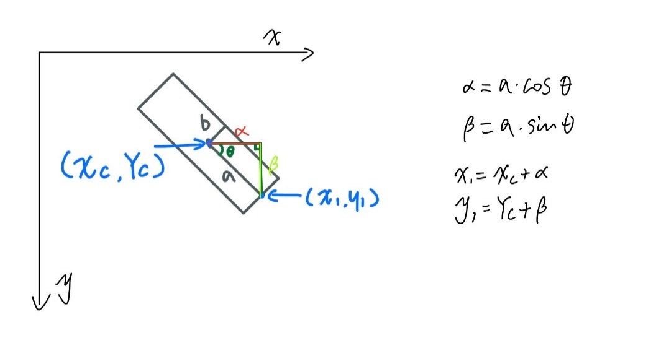

Figure 87: Method for Plotting the Orientation Graph

The $(X_{c} , Y_{c})$ is the Centroid with respect to the origin $(0 , 0)$. $(x_{1} , y_{1})$ is a new point used for plotting the object orientation. From the graph above we can see that $α$ and $β$ are in a positive direction with respect to the x-axis and y-axis. Thus, $x_{1}=X_{c}+α$ and $y_{1}=Y_{c}+β$.

x1 = Xc + a*cos(theta);

y1 = Yc + a*sin(theta);

plot([Xc x1],[Yc y1])

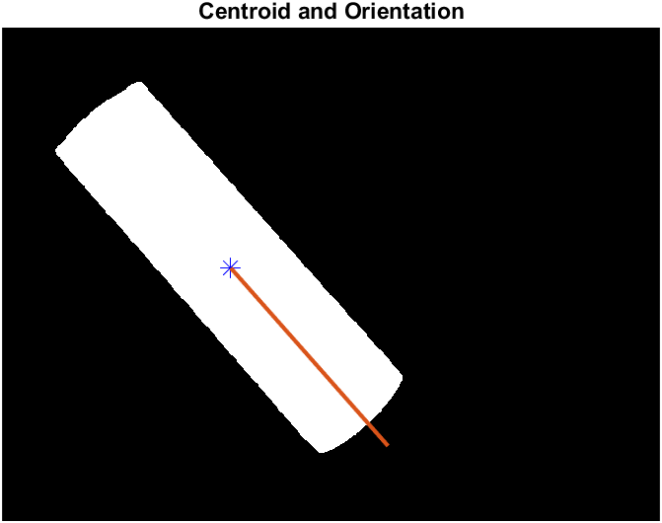

Figure 88: the Centroid and Orientation of the Rectangular Object

We assume the initial axis pointing from centroid to the right and positive direction is anticlockwise. The $θ$ in degree we calculated from the MATLAB is 48.5206 degree shows below:

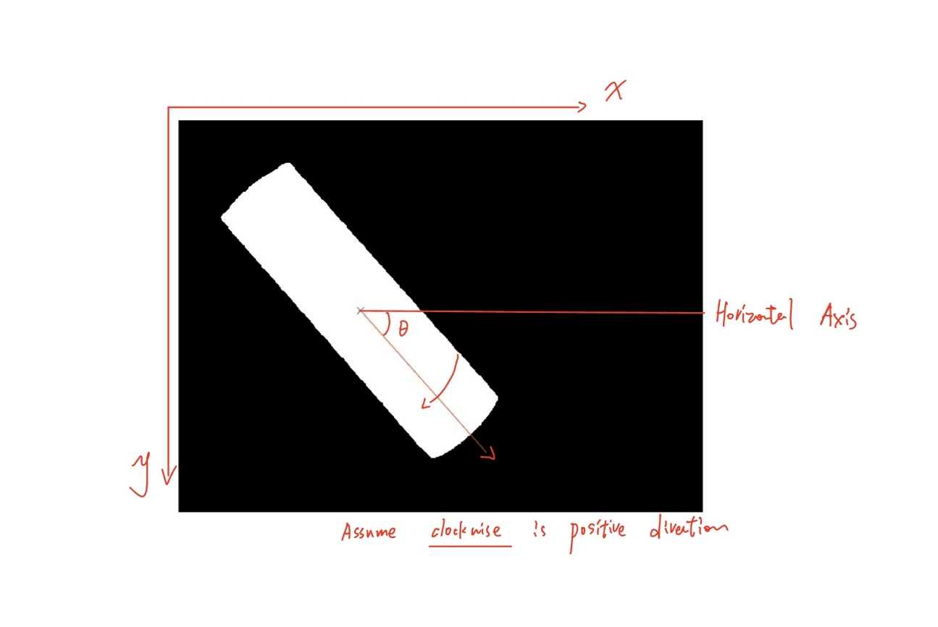

Figure 89: Orientation graph of Object

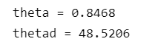

Figure 90: Orientation value in Radius and Degree

**Circularity**

To compute the circularity, we need:

1. perimeter p of the shape being processed

2. the area of the shape, i.e. M00.

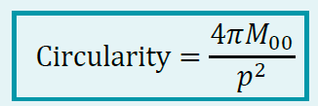

Figure 91: The Equation of the Circularity

To find the perimeter of our object, we should find out the number of white pixels contributing to the perimeter, and the scale of them which accounts for how much exactly each of them contributes, as each white pixel is a square with the length of the side equal to 1 and that length is not the real perimeter length due to the different orientation of the objects. Thus, if we can find how many pixels, we can then know the perimeter of our rectangular.

We want to obtain the sidelines that contribute to the perimeter, which means the line needs to be as thin down to only one pixel wide. We do that by declaring an array to record the positions of pixels contributing to the perimeter. We sample all pixels from four different directions, and even if a certain pixel is recorded more than once the number of pixels would still be correct as in each recording the value of that position in the perimeter array would be set to 1.

Iperi=zeros(m,n);

Perimeterc = 0;

%Top to Bottom

for j=2 : n-1

for i=2 : m-1

if Ibw(i, j) == 1

Iperi(i, j) = 1;

break;

end

end

end

%Bottom to Top

for j=2 : n-1

for i=m-1 : -1 : 2

if Ibw(i, j) == 1

Iperi(i, j) = 1;

break;

end

end

end

%Left to Right

for i = 2 : m-1

for j = 2 : n-1

if Ibw(i, j) == 1

Iperi(i, j) = 1;

break;

end

end

end

%Right to Left

for i=2 : m-1

for j=n-1 : -1 : 2

if Ibw(i, j) == 1

Iperi(i, j) = 1;

break;

end

end

end

If the code detects any white pixel, the white pixels are stored into the Iperi array and the inner for-loop function breaks, the code then starts to scan in the next column/row. When the code scans in the up-down directions of the perimeter, it scans column by column. When scanning for the left-right directions, it scans row by row.

For example, to scan from bottom to top, the code scans each column from the bottom row to the top row. If white pixels are detected, the corresponding position in the Iperi array is marked as 1, and the inner for-loop function breaks, then it starts to scan a new column.

Using the same method for 3 other directions, we can detect all the white pixels that contribute to the perimeter. Then we could calculate the sum of white pixels (i) after scanning the image.

%counting the perimeter

for i = 2 : m-1

for j=2 : n-1

if Iperi(i,j)==1

Perimeterc=Perimeterc+1;

end

end

end

peri=Perimeterc

% figure,imshow(Iperi)

title("Perimeter")

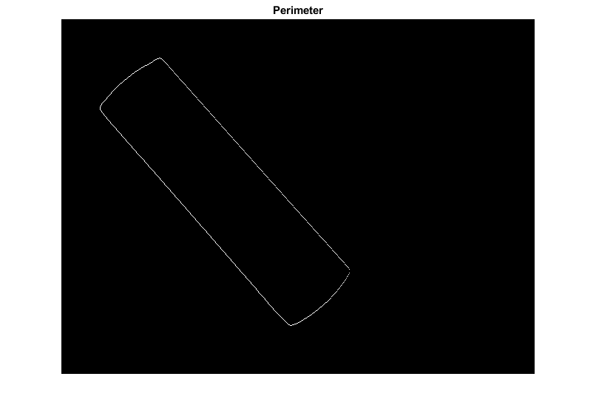

Figure 92: The Perimeter from Four Directions

In the ideal case, the rectangular at the initial position (theta=0) has a perimeter precisely equal to the number of pixels because each pixel has a unit of 1, and the pixels are precisely square. In our case, the rectangular is not in the initial position (as theta= 48.5206), thus its perimeter is not equal to the number of pixels.

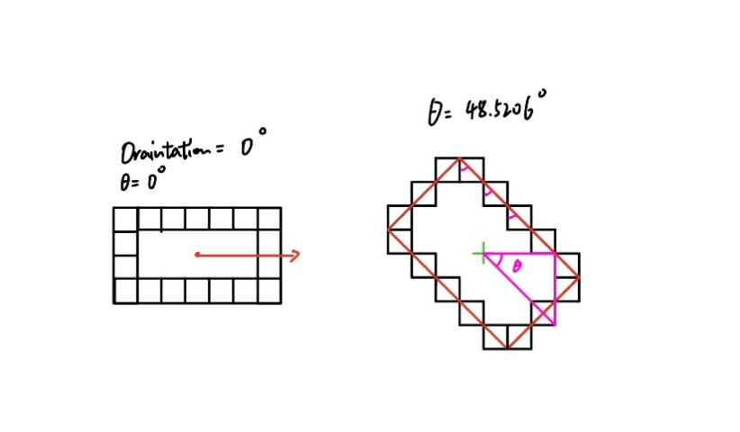

Figure 93: The Perimeter in Pixel Unit

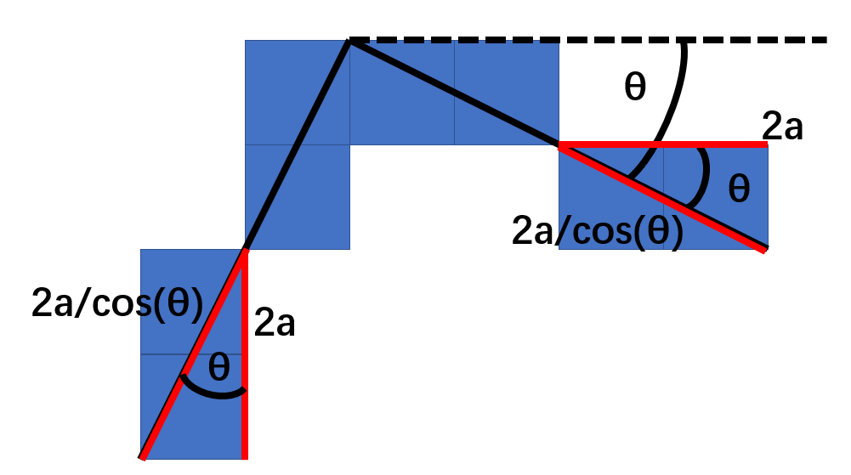

Figure 94: the Diagram Indicating the Relationship between the Pixel Number and Real Perimeter

%converting the perimeter in right value

peri= peri/cos(theta)

In this scenario, the value of perimeter needs to be scaled, as shown above. Thus, the final perimeter needs to be divided by $cosθ$. The perimeter is equal to 1148.9.

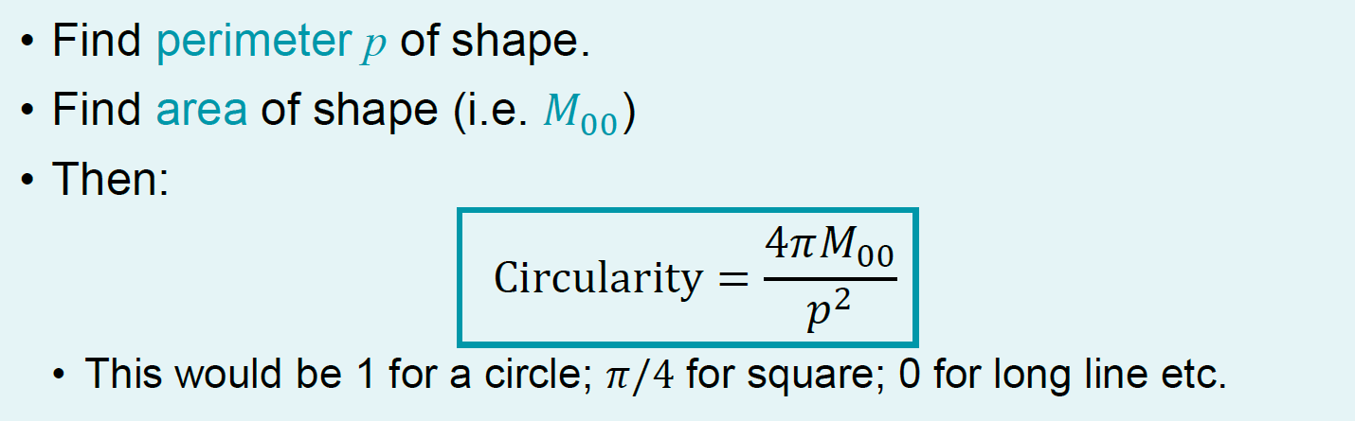

Figure 95: Formulae of Circularity

From the formulae of circularity, we can then implement it into MATLAB and get the circularity of the object.

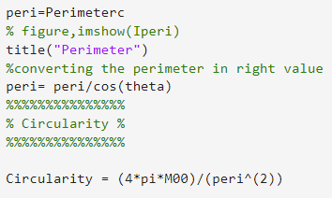

Figure 96: The Code for Thriving the Circularity

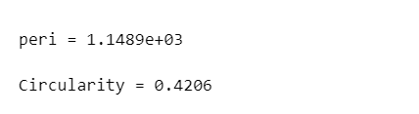

Figure 97: The Values for Peri and the Circularity

Thus, the figure above shows the perimeter and circularity values calculated by MATLAB. From the lecture we can know that the circularity of a square is about 0.785, the circularity of the long line is 0. Therefore, our long rectangular circularity can be proved by these data as 0.4206 is between 0.785 and 0.

**Edges**

Edge is where the brightness level experiences a big change, and we can use differentiation in other words gradient to find where the changes occur.

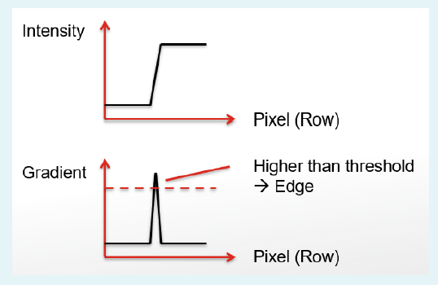

Figure 98: Edge Detection by Using of Differentiation

Intuitively, if the gradient is positive, the masks will mark the edge. If the gradient is negative, the masks fail to detect the edges, thus the absolute value of the gradient value should be taken so that all edges would be captured by the MATLAB.

The following graph shows the code using the Laplacian Edge Detection to find the edge of object.

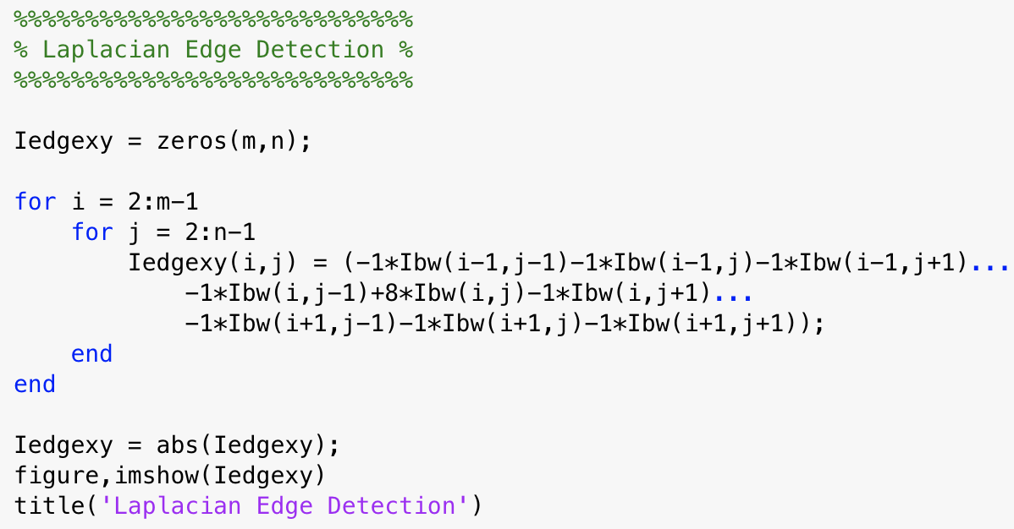

Figure 99: Code for the Laplacian Edge Detection

Then we use Sobel filter to detect the edge, which is shown below. This filter has individual gradients for horizontal and vertical directions. To get the final gradient,

we need to combine both directions to get the combined gradient using equation: $Gradient_{combined}=\sqrt{Gradient_{x}^{2}+Gradient_{y}^{2}}$

For the Sobel filter, we use the pre-processed image Ibw to get clearer edges, whose element values would be either 0 or 1 which stands for black and white. 1 is too small and should be normalized to obtain the general data to plot the Isobelx and Isobely (Isobelx = Isobelx / max(max(Isobelx))*255). Then the Sobel filter could be used for this scenario.

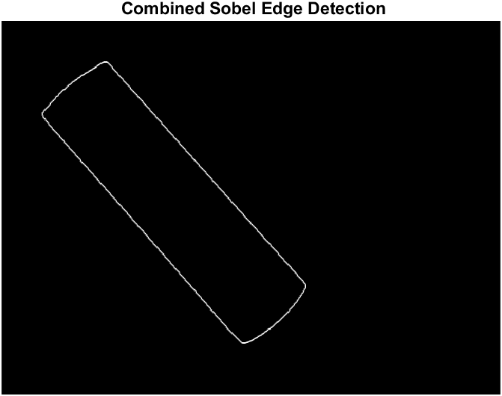

Figure 100: Figure for the Combined Sobel Edge Detection

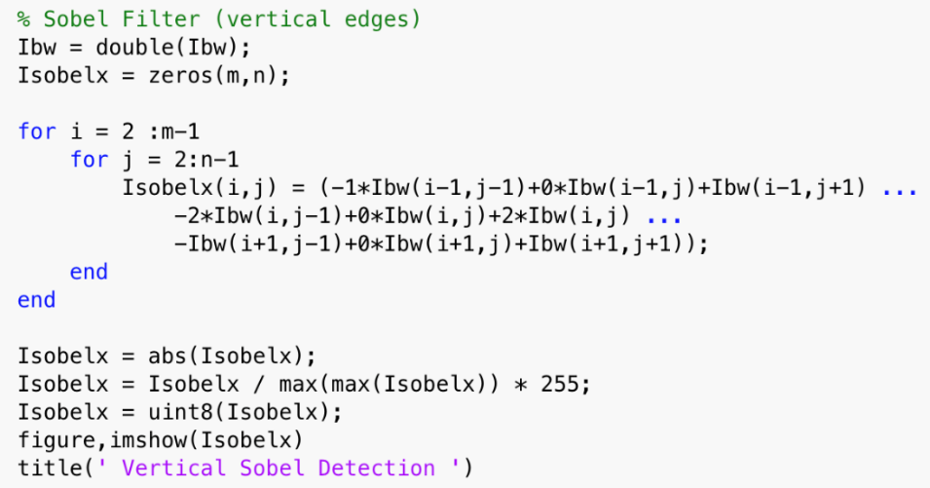

Figure 101: Code for the Vertical part of the Sobel Filter

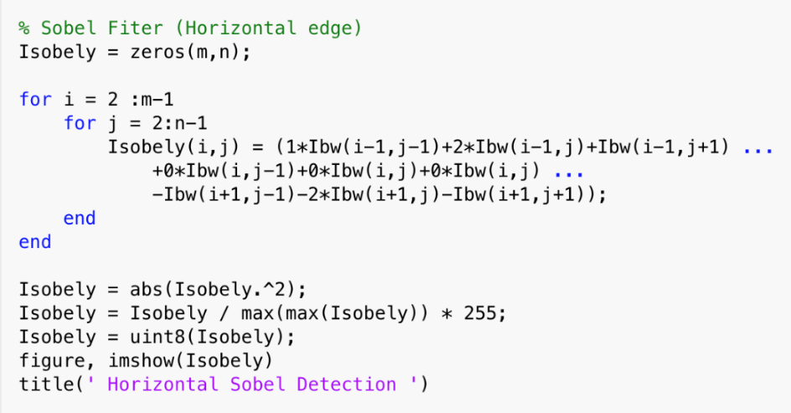

Figure 102: Code for the Horizontal part of the Sobel Filter

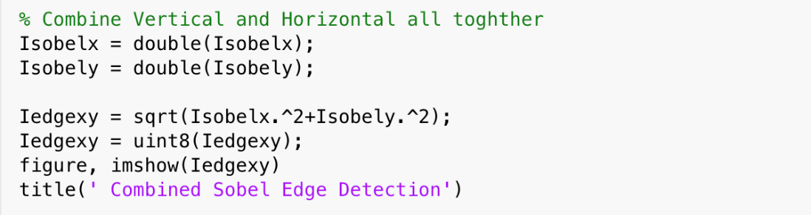

Figure 103: Code for the Combined Vertical and Horizontal part of the Sobel Filter

**Corners**

The Iedgexy graph is obtained in the previous section, and the figure is shown below. For this task, 4 corners need to be marked for the seemingly rectangular object.

This object has the unique property that its four corners are at the four extremities of the graph. So, they all have a maximum or minimum value in rows or columns in which the edge pixels lie. We can then use the built-in functions in Matlab to find the maximum or minimum, and thus the half of the coordinates of the four corners. For example, the top right corner of this object has the minimum value in rows, so we can write code in MATLAB using topRow = min(rows), where "rows" record all the rows in which the edge pixels are present. Using the same method, the rest of the three corners are found.

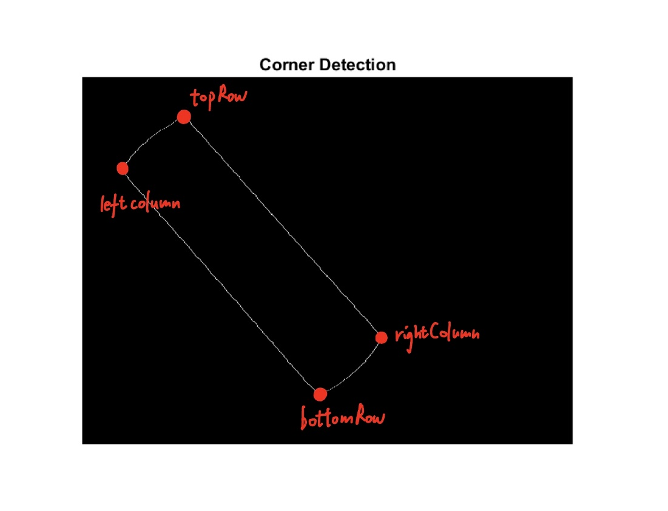

Figure 104: Graph to Indicating 4 Corners

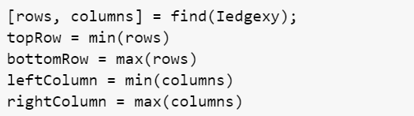

Figure 105: Maximum or Minimum Row of Column Value

The top corner lies in the minimum row, so a for-loop iterates through the whole row to find the column value for this corner point. The loop records the bright pixel and stores 1 in its corresponding position in an array. Using the same method, the rest of the coordinates of the corner points are found.

for j = leftColumn:rightColumn

if Iedgexy(topRow,j) > 1

pos1=[topRow j]

break

end

end

After obtaining 4 corners, we can store their x and y positions into 2 arrays and label 4 corners in the image. Also, use a red square to mark the square occupied by 4 corners.

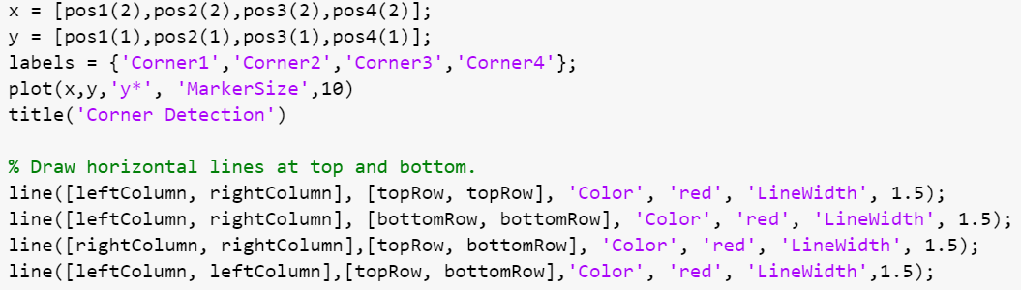

Figure 106: Code for Labelling the Corner

The graph below shows the final corner detection for user.

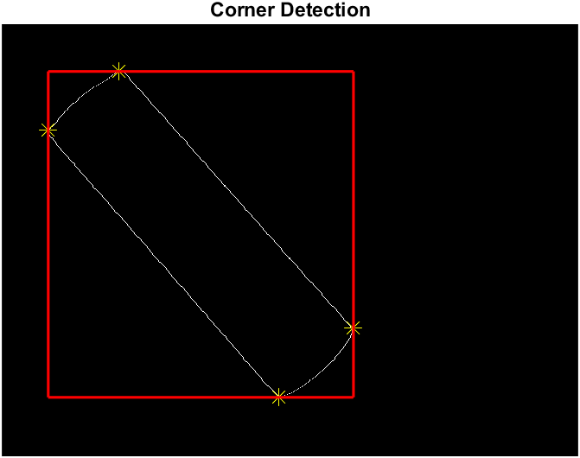

Figure 107: The Graph Indicating that Each Corner Point Touches the Red Line.

**Task 4:**

Task 4 is to find the actual 3D positions of the object with respect to the robot frame $\left[X_{r} Y_{r} Z_{r}\right]$ by the 2D position of the given object in pixel frame ( $x$ and $y$). After getting all the data from the previous tasks, we can combine all the data to calculate the robot's position.

First, we get the values calculated from the previous tasks using MATLAB which are shown below:

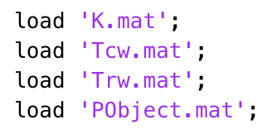

Figure 108: Load Data from Previous Tasks in MATLAB

The relationship between pixel coordinate and world coordinate is shown below:

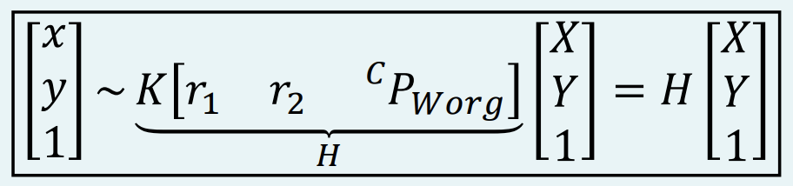

Figure 109: the Relationship between Pixel Coordinate and World Coordinate

We use the equation above to calculate the H-matrix, to do that we get the $r_{1}$, $r_{2}$, $K$ and $CPworg$ first. Extract them from the loaded data.

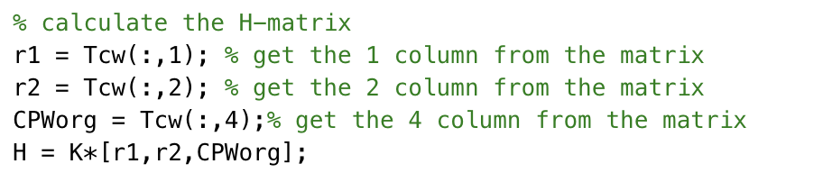

Figure 110: MATLAB code for getting the H-matrix

Since the relationship between world coordinate and pixel coordinate is:

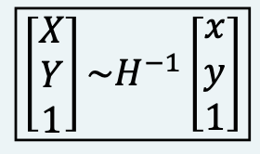

Figure 111: the relationship between world coordinate and pixel coordinate

Then import object position coordinates x and y from Pobject.m from task 3, after that the position of the object can be calculated.

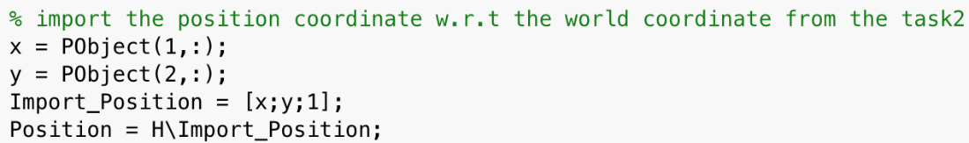

Figure 112: MATLAB code for getting the position of the object

The matrix needs to be normalized to make the last row on the RHS become 1, so that the scale of the object taken in the picture is the same as the real object we choose. The position of the object we get is in 2D coordinate after normalization, so we need to transfer it to the 3D form and let the coordinate with respect to the robot frame. As from figure 58 we can know the relationship between the robot coordinate and the world coordinate, then we can calculate the robot coordinate by multiplying the Trw matrix obtained in task 3 and the world coordinate together.

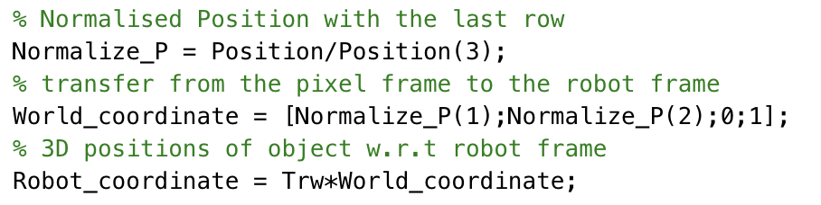

Figure 113: MATLAB code for calculate the Robot coordinate

Finally, we can get the correct robot coordinate base on the image of the object we have taken, which is:

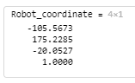

Figure 114: The Final Values of the Robot Coordinates

**Task 5:**

In Task 5 we repeated the methodology used in task 1 to perform camera calibration, except in this trial we used our own photos as data rather than someone else's. For an idea of the mathematical basis, return to Task 1 where a run through of the theory as well as the code we have implemented is explained.

In this experiment, we use photos obtained by the camera that the robot will be using as displayed. The first image has the checkerboard in the working position of the robot.

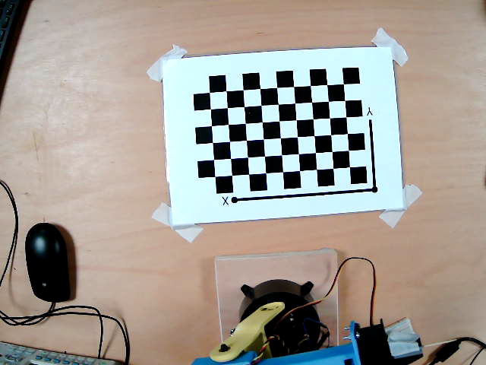

Figure 115: Working Position of the Checkerboard

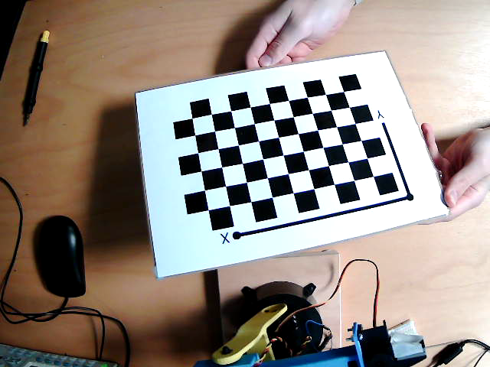

Figure 116: Position 1 for Calibration

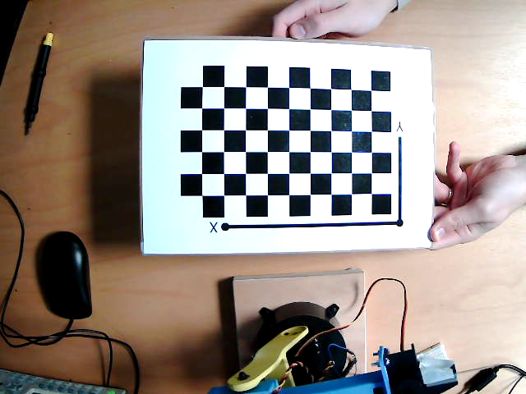

Figure 117: Position 2 for Calibration

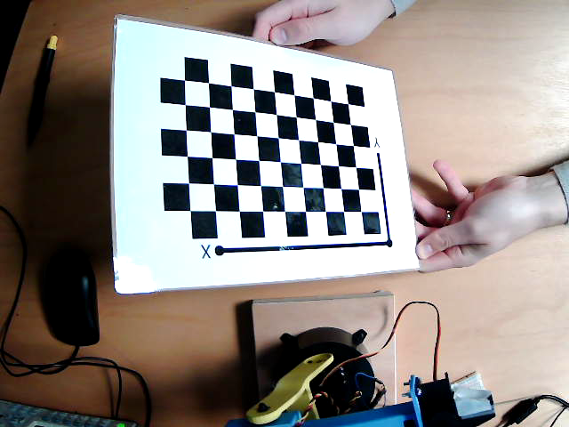

Figure 118: Position 3 for Calibration

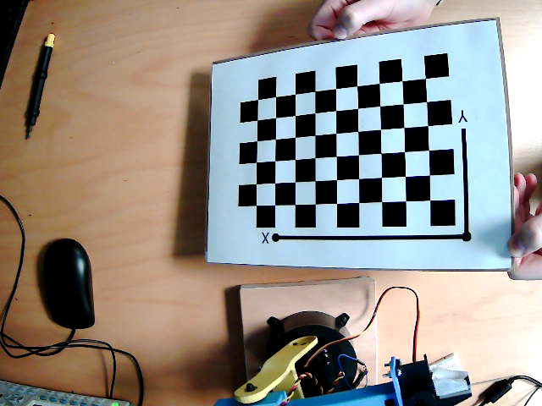

Figure 119: Position 4 for Calibration

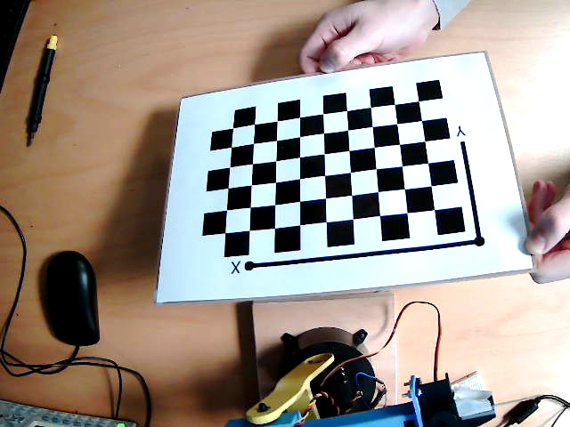

Figure 120: Position 5 for Calibration

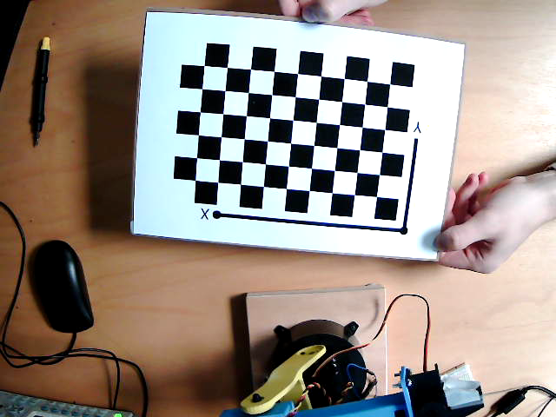

Figure 121: Position 6 for Calibration

In order to get these images using the camera connected to the computer, the following code was run:

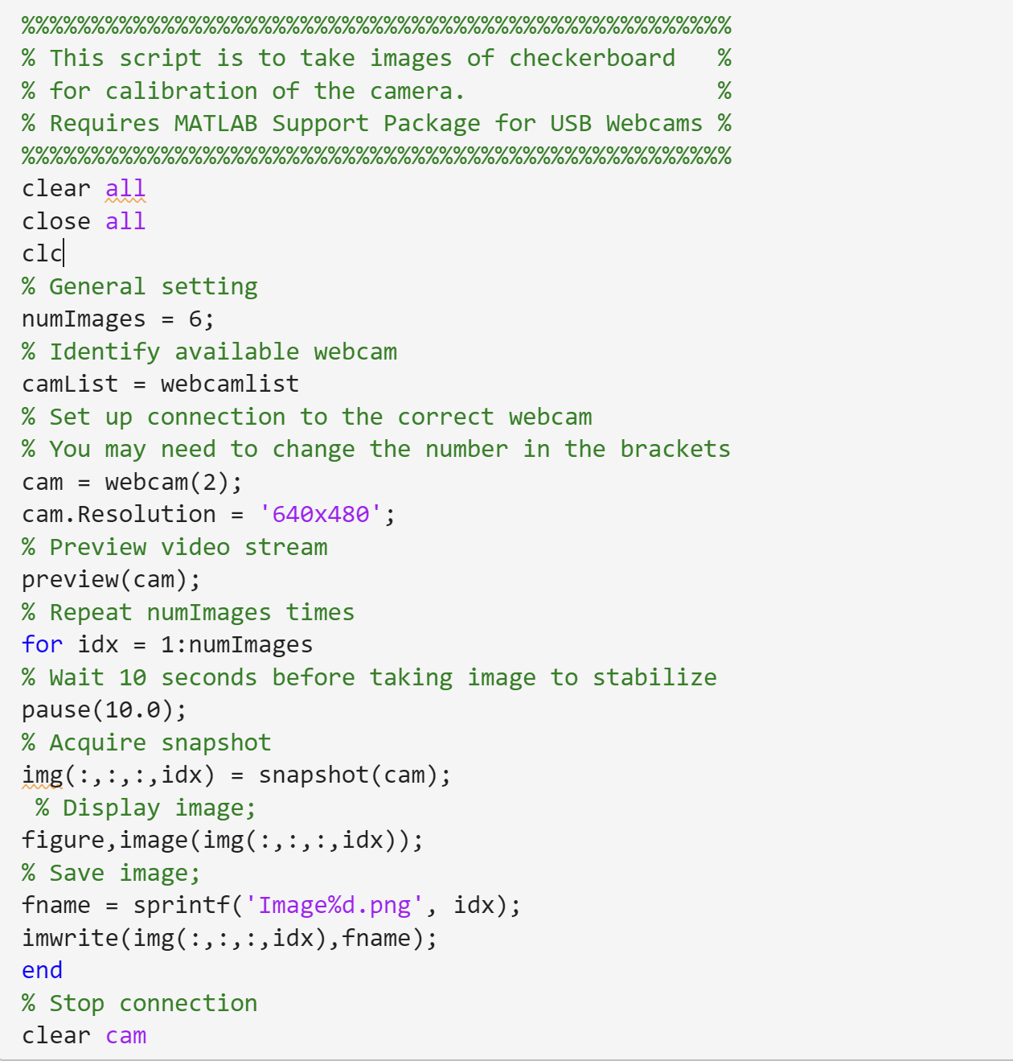

The code can then be run with the results shown as follows.

Intrinsic:

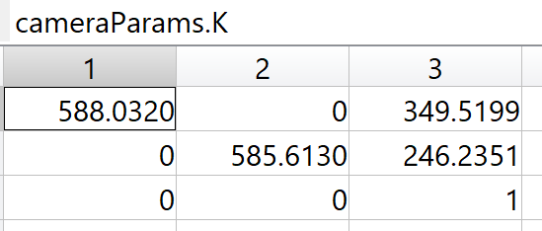

Figure 122: Intrinsic Parameters Calculated by the Toolbox

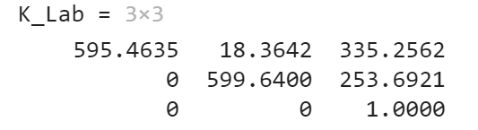

Figure 123: Intrinsic Parameters Calculated by the H Matrices

Extrinsic:

Image1:

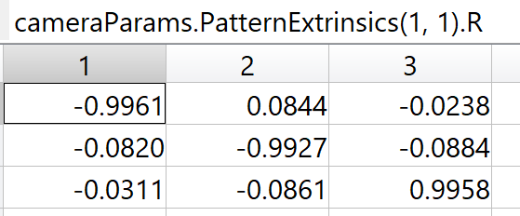

Figure 124: Extrinsic Parameters of the First Image Calculated by the Toolbox-Rotational Matrix

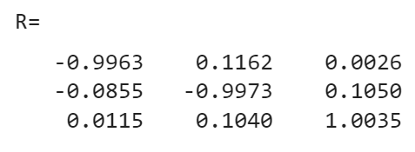

Figure 125: Extrinsic Parameters of the First Image Calculated by the H Matrix-Rotational Matrix

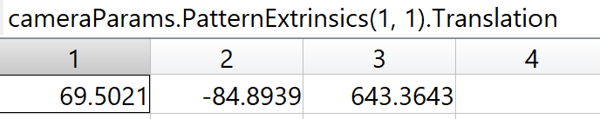Figure 126: Extrinsic Parameters of the First Image Calculated by the Toolbox-Translation Vector

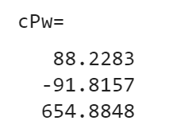

Figure 127: Extrinsic Parameters of the First Image Calculated by the H Matrix-Translation Vector

Image 2:

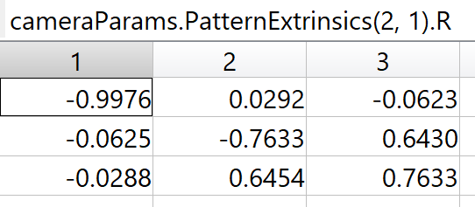

Figure 128: Extrinsic Parameters of the Second Image Calculated by the Toolbox-Rotational Matrix

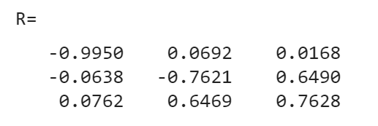

Figure 129: Extrinsic Parameters of the Second Image Calculated by the H Matrix-Rotational Matrix

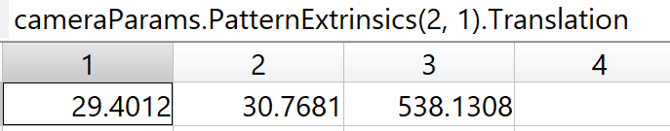Figure 130: Extrinsic Parameters of the Second Image Calculated by the Toolbox-Translation Vector

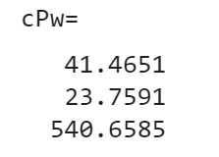

Figure 131: Extrinsic Parameters of the Second Image Calculated by the H Matrix-Translation Vector

Image 3:

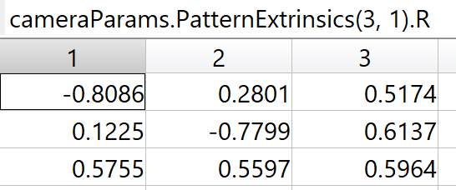

Figure 132: Extrinsic Parameters of the Third Image Calculated by the Toolbox-Rotational Matrix

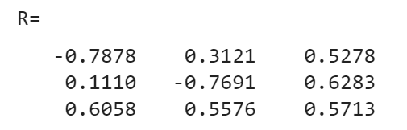

Figure 133: Extrinsic Parameters of the Third Image Calculated by the H Matrix-Rotational Matrix

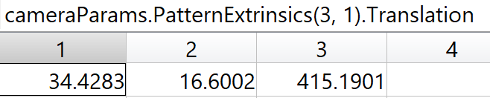

Figure 134: Extrinsic Parameters of the Third Image Calculated by the Toolbox-Translation Vector

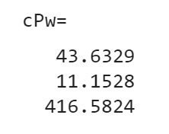

Figure 135: Extrinsic Parameters of the Third Image Calculated by the H Matrix-Translation Vector

Image 4:

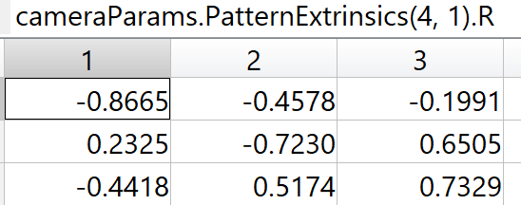

Figure 136: Extrinsic Parameters of the Fourth Image Calculated by the Toolbox-Rotational Matrix

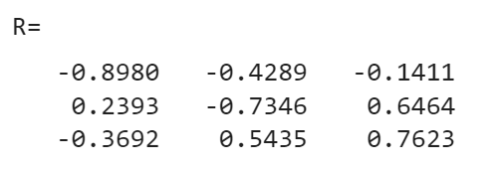

Figure 137: Extrinsic Parameters of the Fourth Image Calculated by the H Matrix-Rotational Matrix

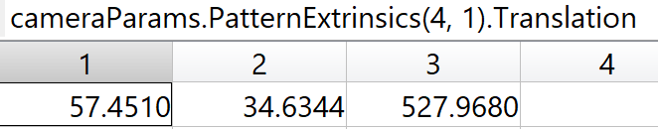Figure 138: Extrinsic Parameters of the Fourth Image Calculated by the Toolbox-Translation Vector

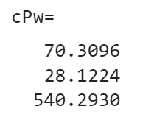

Figure 139: Extrinsic Parameters of the Fourth Image Calculated by the H Matrix-Translation Vector

Image 5:

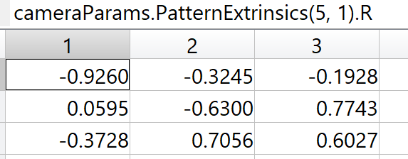

Figure 140: Extrinsic Parameters of the Fifth Image Calculated by the Toolbox-Rotational Matrix

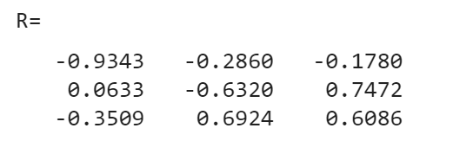

Figure 141: Extrinsic Parameters of the Fifth Image Calculated by the H Matrix-Rotational Matrix

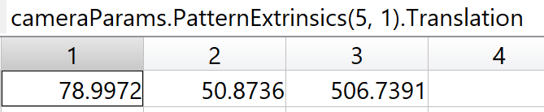Figure 142: Extrinsic Parameters of the Fifth Image Calculated by the Toolbox-Translation Vector

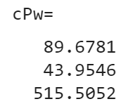

Figure 143: Extrinsic Parameters of the Fifth Image Calculated by the H Matrix-Translation Vector

Image 6:

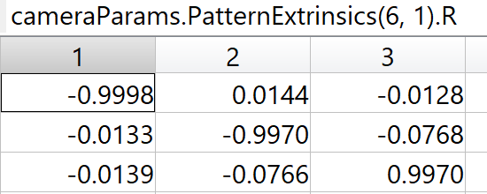

Figure 144: Extrinsic Parameters of the Sixth Image Calculated by the Toolbox-Rotational Matrix

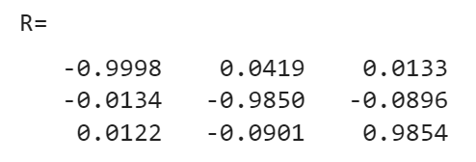

Figure 145: Extrinsic Parameters of the Sixth Image Calculated by the H Matrix-Rotational Matrix

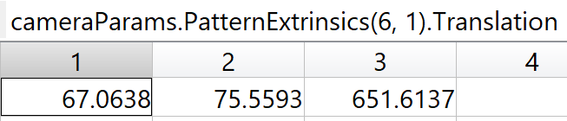Figure 146: Extrinsic Parameters of the Sixth Image Calculated by the Toolbox-Translation Vector

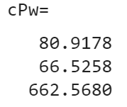

Figure 147: Extrinsic Parameters of the Sixth Image Calculated by the H Matrix-Translation Vector

Image working position:

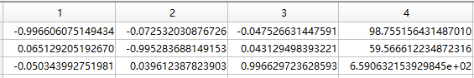

Figure 148: Extrinsic Parameters of the Working Position Calculated by the H Matrix-Translation Vector

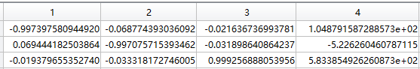

Figure 149: Extrinsic Parameters of the Working Position Calculated by the Toolbox-Translation Vector

We can see that there are some differences between our calculated values using the H matrix and the camera toolbox, but this is not significant since it may be caused by the accuracy (number of decimal places) of figures and numbers used. This suggests that the solution through the H matrix works. The challenge was that the pictures need to be in a relatively dark environment since the light in the surroundings imposes uncertainties on the scanning process of the checkerboard as the reflection would change the value of the black square areas, otherwise the extrinsic parameters may have an unexpected minus sign and the transition vector in it may have a false value.

**Task 6:**

Task 6 relates to the work completed in task 2. The difference, however, is that in task 2, the probing was done for us, and the values were given to us for the robot's position in the Robot coordinate system. In this task, we need to do the calibration by using the potentiometers to control the robot's movement and identify the robot's positioning according to the robot coordinate system, and we need to add the length of the toothpick to the robot arm length. The torque of the servos was large enough that a slightly violent move would break the toothpick, which made the process more difficult and longer.

For robot calibration, we must find the relationship between the 3D robot frame and the 3D world frame. When the TCP touches the corner point I, we can find out the position of the TCP $\left[X_{ri} Y_{ri }Z_{ri}\right]$ With respect to the robot frame by using forward kinematics. The position of the corner point $\left[X_{i} Y_{i }0\right]$ with respect to the World frame are known.

An issue we encountered was that the robot's movements could sometimes be quite erratic, and it was challenging to be very accurate when probing the checkerboard. This led to some measurement errors in the robot coordinate system. We can reduce this error by taking multiple measurements, as the uncertainty will even itself out over the more measurements you take.

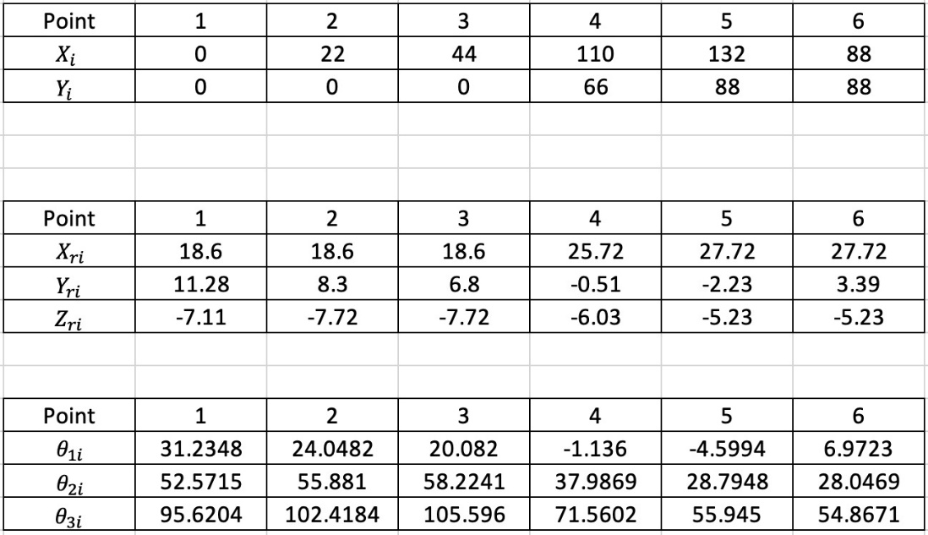

Figure 150: Points in World Frame



Figure 151: Points in Robot Frame

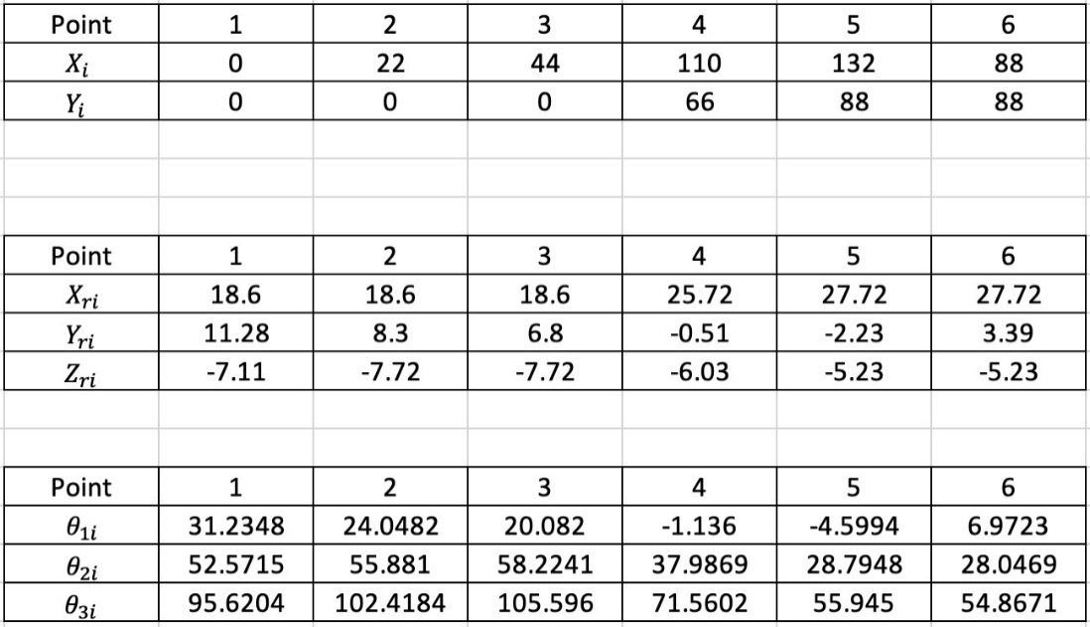

Figure 152: Joint Angle Values for Each Corner Points

The graph below shows the relationship between the robot frame and the world frame.



Figure 153: Relationship between the Robot Frame & World Frame

Six points are sampled to give their coordinates in world origin and in the robot frame. The Arduino code used here is using a potentiometer and directly outputs the robot frame coordinates, so there’s no need to use forward kinematics. However, the angles are still derived here for convenience.

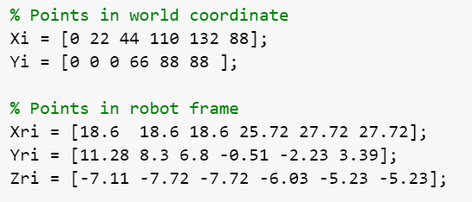

Figure 154: Probed values for the robot frame & world frame

The figure above displays the world coordinate points used and the robot coordinate points found by probing the board with the robot.

To solve for two unknown parameters $ρ$ and $t$, we use the method proposed by Cashbaugh et al.



Figure 155: Individual linear equations



Figure 156: Obtain unknown parameters by minimizing the square of errors



Figure 157: The minimum value occurs when the derivatives are zero



Figure 158: Transformation of the equation and its matrix form

Then rewrite the equation and write it into matrix form:



Figure 159: The intermediate matrix in MATLAB

As we have six points selected on the checkboard, $n=6$

To calculate matrix $\left[ρ_{11} ρ_{12} t_{x}\right]$, we use the $E_{X}^{2}$ and the equation below is from the lecture notes (page 88).



Figure 160: matrix form for $E_{X}^{2}$ to calculate the rotation and translation parameters



Figure 161: the MATLAB code to calculate $ρ_{31}$, $ρ_{32}$, $t_{x}$

To calculate matrix $\left[ρ_{21} ρ_{22} t_{y}\right]$, we use the $E_{Y}^{2}$ and the equation below is from the lecture notes (page 89).



Figure 162: matrix form for $E_{Y}^{2}$ to calculate the rotation and translation parameters



Figure 163: the MATLAB code to calculate $ρ_{21}$, $ρ_{22}$, $t_{y}$

To calculate matrix $\left[ρ_{31} ρ_{32} t_{z}\right]$, we use the $E_{Z}^{2}$ and the equation below is from the lecture notes (page 90).



Figure 164: matrix form for $E_{Z}^{2}$ to calculate the rotation and translation parameters



Figure 165: the MATLAB code to calculate $ρ_{21}$, $ρ_{22}$, $t_{z}$

Finally, $\left[ρ_{13} ρ_{23 }ρ_{33}\right]$ can be calculated as the cross product of two vectors below:



Figure 166: Equation for calculating $\left[ρ_{13} ρ_{23 }ρ_{33}\right]$



Figure 167: Calculation for the $\left[ρ_{13} ρ_{23} ρ_{33}\right]$

The code above in MATLAB to calculate the required parameters.

 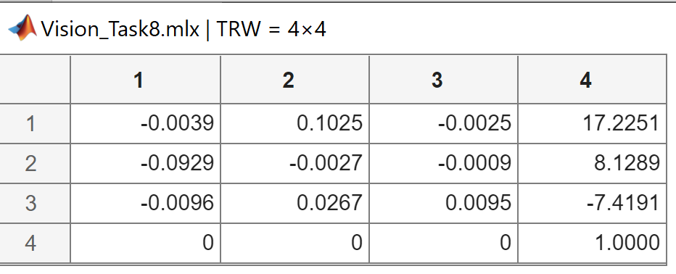

Figure 168: General expression for the Trw and final answer of the Trw matrix

The left figure above is the general matrix expression for the unknown parameters and the right figure is the final values displayed by the right-hand side matrix.

**Task 7:**

This task aims to find the position and orientation of an object. The object we use is a light-purple eraser.

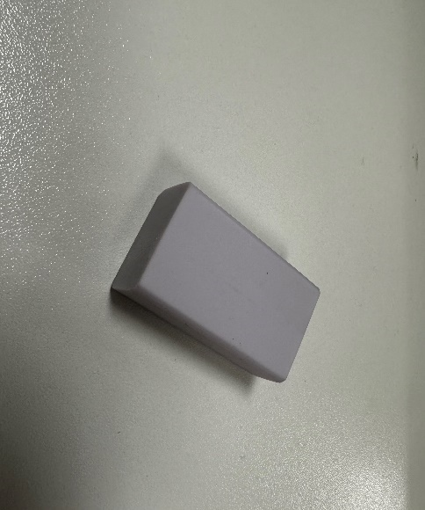

Figure 169: Light-purple eraser Object

In the task7 experiment, we encountered a difficulty. The image we had taken from the camera has a great quantity of other clutter in the background of this object taken in real life (background noise). In image recognition, our code could not determine which particular object in the picture we were trying to identify. Thus, we could introduce a new method (Differencing) from lecture to solve this problem. Differencing is a pixel point operation, but this method requires multiple images as Output = Input1 – Input2.

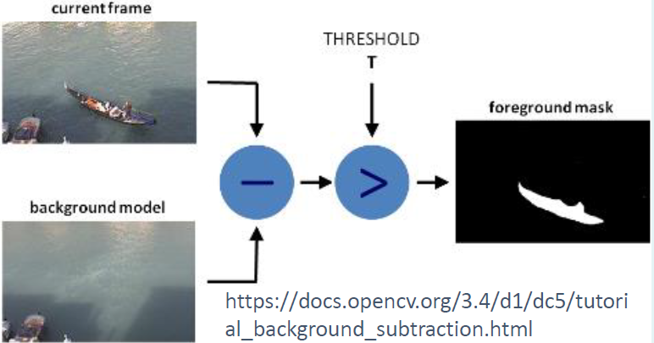

Figure 170: The Process to get the Final image without Background noise

This method is used to detect the differences in similar images. We could take two images with the same background. The first image is called object1 with our object that we would like to investigate the position and orientation. The second image is called background1 without the object but with the same background as the first image. Thus, we could use $I=C(object1)-B(Background1)$ to get the object that we want to investigate.

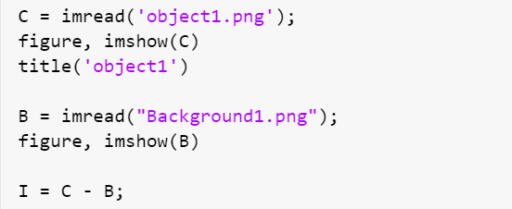

Figure 171: MATLAB code to detect the Differences in two similar images

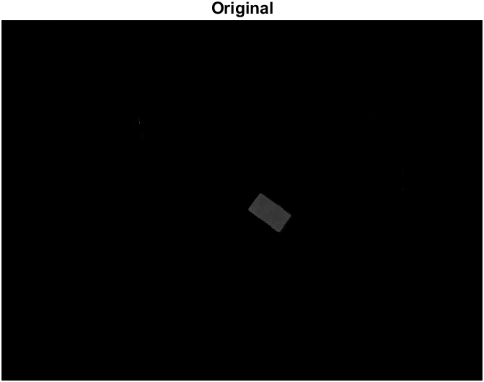 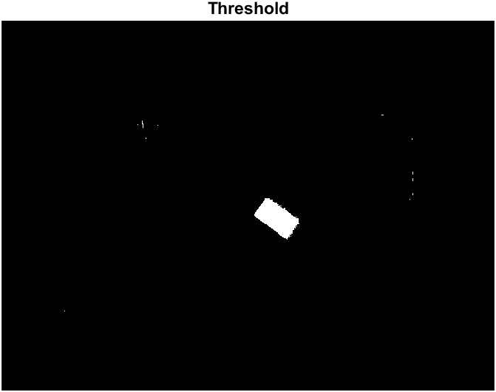

Figure 172: The original graph after Grey scale on the left and after Thresholding on the right

After the differencing method then we could obtain the original graph with the object that we would like to investigate. From the graph on the left, we could let the background becomes pure black (0) and the object (a bit white rectangular shape) becomes pure white (255). Note that the threshold needs to be adjusted if needed. Thus, we could write the thresholding mask code shows below:

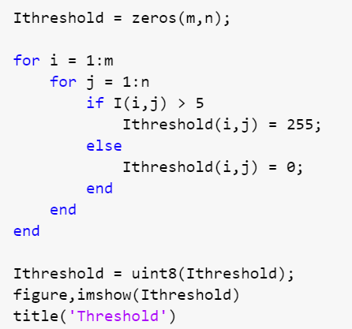

Figure 173: MATLAB code for Thresholding

After filtering out the noises by using the median filter, we can find the position and orientation of this object. The calculation of centroid method has been derived at Task 3 by using of the moment method.

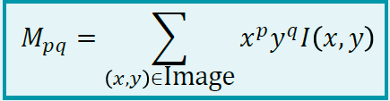

Figure 174: The p-q-th Moment of an image)

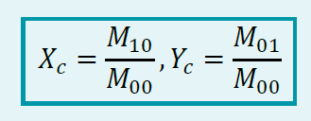

Figure 175: Formulae for the Centroid point

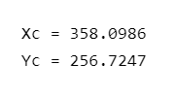

Figure 176: The Centroid point of the eraser

To investigate the orientation of our object, we could use Central Moment, Inertia Matrix and Ellipse from Task 3.

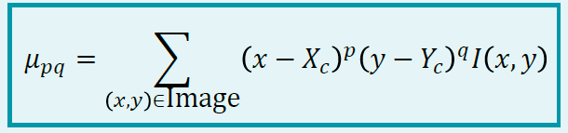

Figure 177: Formulae for the Central Moment

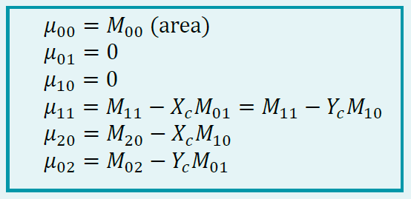

Figure 178: Formulae for $μ_{00}$, $μ_{01}$, $μ_{10}$, $μ_{11}$, $μ_{20}$, $μ_{02}$

$$μ_{02}$$



Figure 179: The Matrix expression for the Inertia of a Blob $J$

$$J$$

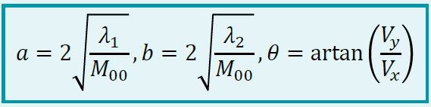

Figure 180: Ellipse parameters obtained from the Inertia Matrix

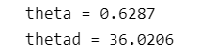

Figure 181: The Orientation value in Radius and Degree of the eraser

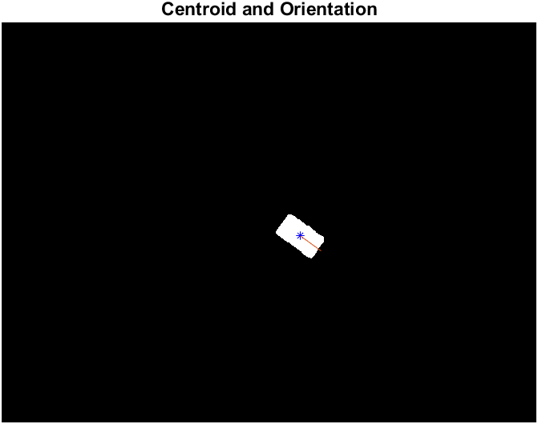

Figure 182: The Centroid and Orientation of the eraser

From the graph above, the object with $36.0206°$ rotated in clockwise direction from horizontal axis.

**Task 8:**

In task 8 we repeat task 4 with our own data. With the K_Lab.mat, Tcw_Lab.mat, Trw_Lab.mat, and Object.mat obtained previously, we find the actual 3D positions of the rubber (object1) with respect to the robot frame by the 2D position of the given object in the pixel frame (x and y).

First, we get the values calculated from the previous tasks using MATLAB which are shown below:

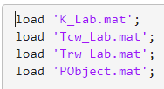

Figure 183: The Code Loading the Data

In order to find the actual 3D position of the object, we need first calculate the camera matrix using the equation below:



Figure 184: The Equation for the Camera Matrix H

When calculating the H-matrix, we get the r1, r2, K and CPWorg first from task 1. Extract them from the loaded data.

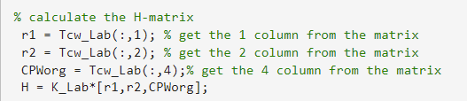

Figure 185: Data Extraction

Then the world coordinate from task 2 is extracted to calculate the position of the object.



Figure 186: Data Extraction of the Object Position

The matrix needs to be normalized to make the last row on the RHS 1. Also, from figure 58 we can know the relationship between the robot coordinate and the world coordinate, then we can calculate the robot coordinate by multiplying the Trw matrix obtained in task 3 and the world coordinate together.

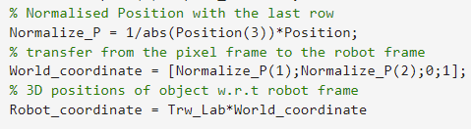

Figure 187: Normalization and Multiplication

The final robot coordinate is shown below：

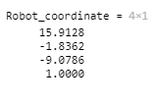

Figure 188: Result of Calculation for the robot coordinate

**Task 9:**

In this task, a trajectory needs to be derived to give a time profile of the movement position of the robot arm in order not to hurt the robot itself and surroundings, or cause damage to the servos.

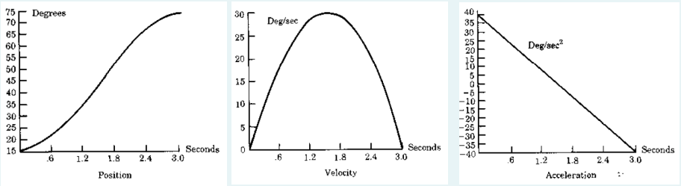

Figure 189: Time Profile in Figures

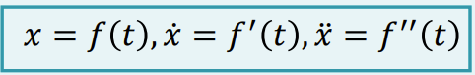

Figure 190: Time Profile Parameters—Displacement, Speed and Acceleration

Here we use the Cartesian Space Schemes. Cartesian Space Schemes is good at enforcing the shapes of the path and the orientation of the joints, but continually calculating the inverse kinematic makes it computationally expensive. It also suffers from singularities and workspace-related problems, such as unreachable intermediate points. An alternative is Joint Space Schemes, where the joint angles are compiled. It’s easier to calculate but may result in a collision.

In order to make sure the velocities of the robot at the start and end points are continuous to avoid jerky movements and ensure that they are zero, the cubic polynomial method is used, which is shown in figure 191.

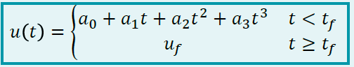

Figure 191: the Cubic Polynomial Equation

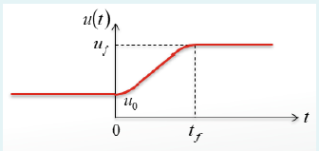

Figure 192: the Trend of Cubic Polynomial Equation

Now that we have four constraints, we can substitute the u(t) equation into them to get 4 simultaneous equations. By differentiating, we get the simplified equations.

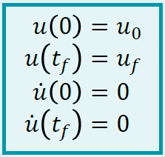

Figure 193: the Four Constraints that Four Parameters Need to Satisfy

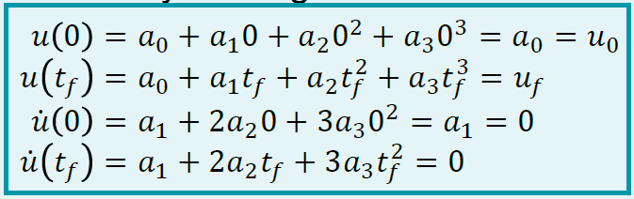

Figure 194: Four Simultaneous Equations to Solve $a_{0}$ to $a_{3}$

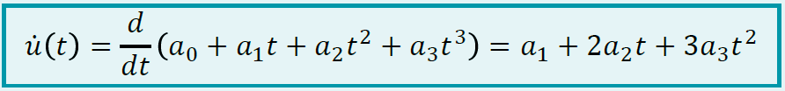

Figure 195: Differentiation of $u\left(t\right)$

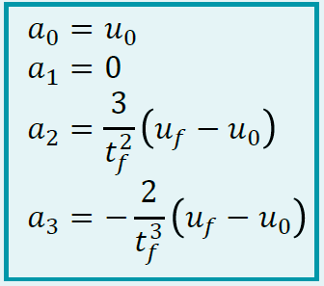

Figure 196: Solutions to the Simultaneous Equations for Parameters $a_{0}$ to $a_{3}$

After getting these expressions for $a_{0}$ to $a_{3}$, we can substitute our values into them. The workflow of substitution and realizing the trajectory is as follows. Suppose the position with respect to the world frame is already obtained from task8.

First, we declare the variables.

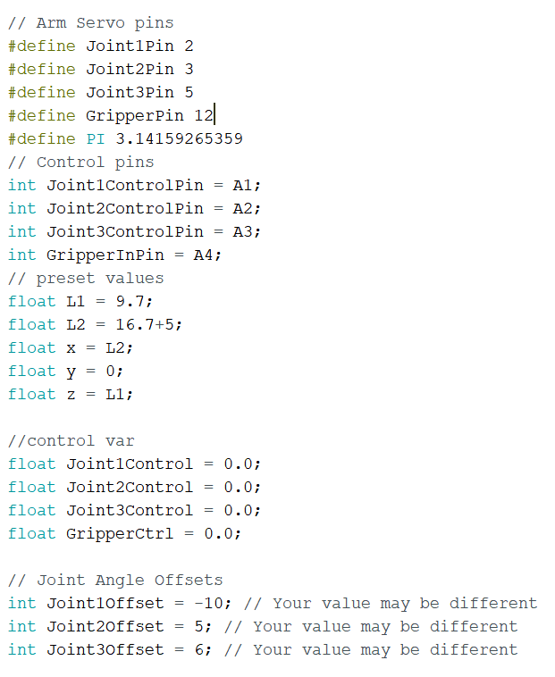

Figure 197: the Code for Setting Variables

Second, we set arrays for x, y and z positions at 50 different time stamps respectively, which store the trajectory positions for each trajectory movement.

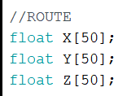

Figure 198: Setting Arrays for Three Different Dimensions

Third, we calculate trajectories in a single function which will be used later.

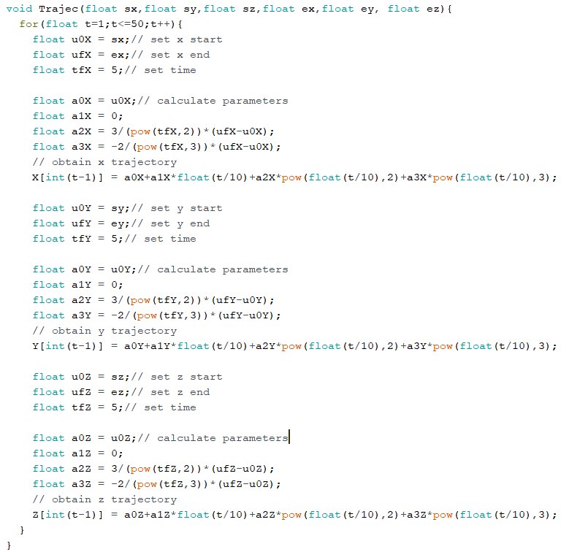

Figure 199: Calculate Trajectories

Fourth, we rewrite the inverse kinematics in the IDE (in a single function writing servo angles).

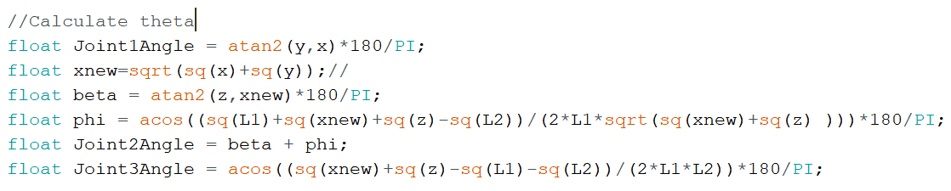

Figure 200: Rewriting Inverse Kinematics

Fifth, attach servos and set the arm to the initial position in the setup function.

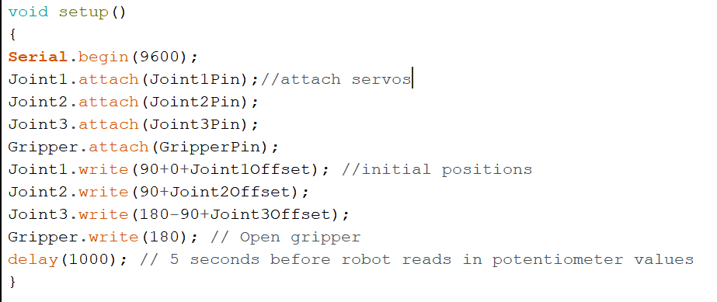

Figure 201: Attaching Servos and Setting Initial Position

Sixth, in the loop function, write two parts of routes with trajectory calculation function and the servo write function set previously to execute them repeatedly.

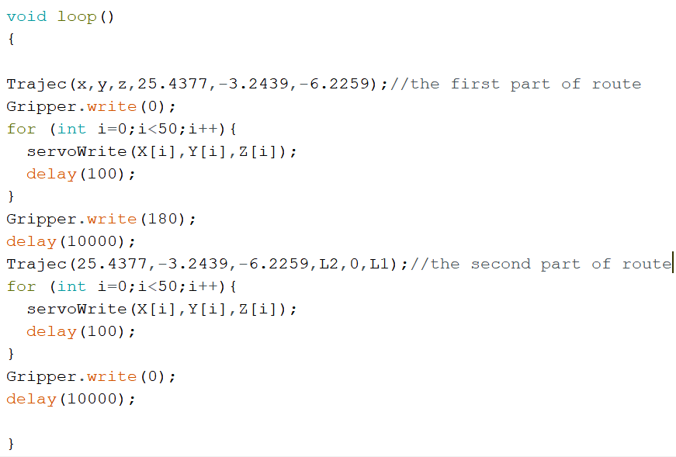

Figure 202: Execution of the Trajectories

The robot arm successfully executes the route, though jiggling happens it’s largely because the arm is not fixed tightly, thus the code is proved to be valid.

**Reference**

All the equations figures with blue background are from the slides given.